E-KODAK: A PHOTOGRAPHY MANAGEMENT SYSTEM WITH REAL TIME TRACKING

A Capstone Project Presented to the Faculty of the
College of Technology

CEBU TECHNOLOGICAL UNIVERSITY – NAGA EXTENSION CAMPUS

Central Poblacion, City of Naga, Cebu 6037 Philippines

In Partial Fulfillment of the Requirements for the Degree

BACHELOR OF SCIENCE IN INFORMATION TECHNOLOGY

Mc Gerald Von Rich B. Nebril Kurt Andrie J. Dugaduga

Mark June A. Repunte

May 2026

Chapter 1

THE PROBLEM AND ITS SCOPE

Introduction

Photography services have a very crucial role to play in documenting and milestones in a person’s life, such as weddings, pre-wedding shoots, debut events, birthday celebrations, corporate events, among other key events. It is not only a way of recording images in a visually oriented society but it also a form of art and a vital branding tool. It has a huge impact on consumer engagement, especially if the images are of high quality (Forbes, 2023). The field of photography has continued to grow, especially nowadays whereas people and organizations have come to realize the importance of the field, both for individual and business use. The global market for photography services has continued to grow steadily, especially because of the increase in the use of digital content and the use of social media (Forbes, 2023).
With the development of information technology, some service-oriented enterprises have begun to use web-based management systems to improve efficiency and customer service quality. Studies have shown that the application of digital transformation in enterprise management systems can help reduce operational burden, improve accuracy, and improve transaction speeds (Verhoef et al., 2021).

In addition, the application of web-based management systems can improve the efficiency of enterprise core operations, such as bookings, scheduling, photo

output monitoring, and digital media organization, to improve service quality (Laudon & Laudon, 2022). Moreover, QR code technologies have been increasingly applied in enterprise operations for tracking, identification, and automation due to their convenience and reliability (Rouillard, 2008). This helps to improve the efficiency of accessing enterprise information through smartphone devices. At the same time, SMS notification services and digital content-access features have been commonly applied to improve communication between enterprises and customers.

Despite all these technological developments, many service providers of photography services still use manual systems for booking, photo organization, and client coordination. In many cases, the client needs to make an inquiry about the availability of the photographer, assigned schedules, type of service offered, photo output status, and access to event collections such as yearbook photos. Research indicates that using a manual system can increase the chances of error and make the service less efficient compared to using an automated system (Laudon & Laudon, 2022).

To address these challenges, the researcher proposes the capstone project, E-KODAK: A Photography Management System with Real-Time Tracking. As a comprehensive solution, this project encompasses the development of both a web-based portal and a dedicated mobile application with modules for booking management, QR-based tracking, SMS notification, photo output management, and digital yearbook handling.

This integrated system will enable clients to seamlessly book services online, choose photographers, track photo outputs using QR codes, and view completed yearbook content across their preferred devices. It will also allow photographers to upload or send captured photos to the staff, allow staff to insert and organize approved photos into the yearbook, provide real-time status monitoring, and send automated SMS notifications for timely updates.

Project Context

This project focuses on E-KODAK: A Photography Management System with Real-Time Tracking, a web-based photography studio platform deployed at https://ekodakdeployment.netlify.app/. The system is intended to support Rafael Orbigoso Photography Services by bringing key studio activities, service presentation, customer account access, booking coordination, customer records, and operational management into a more organized digital workflow. The deployed website is the reference point for describing the current system; features that are not visible or verified in the deployment are treated as planned or conditional rather than confirmed.

Furthermore, as part of its integrated platform design, a companion mobile application will be provided; clients can use this app to scan their generated QR code and instantly view real-time updates regarding their orders.

On the other hand, the system will enable the administration a centralized platform to update bookings, photo outputs, transaction records, photo or product release, and yearbook content. Photographers will also be provided with a complete functionality of providing their available schedules and transferring photos into the admin portal for yearbook insertion. The system will also support SMS notifications to clients regarding the progress and availability of their photos.

The study is set to begin in February 2026 and is expected to be completed by December 2026. The study will take place in the operating environment of Rafael Orbigoso’s Photography Services.
The researchers are proposing this system to eliminate the inefficiencies

brought about by manual operations, social media-based transaction systems, and scattered photo coordination processes. The proposed system aims to help modernize photography service management through digital automation. Digital automation helps in reducing administrative burden, improving transaction speed, and increasing the accuracy of information (Verhoef et al., 2021). The proposed system aims to improve efficiency, record accuracy, transaction time, digital photo organization, and customer satisfaction.

The research will adopt the Agile methodology approach, which is favorable for iterative development, feedback, and the ability to adapt to changing needs.

Agile methodologies are known to improve the quality of software products and ensure that software development meets the needs of the users through incremental development (Beck et al., 2001)

Purpose and Description

The main purpose of this study is to develop and document E-KODAK: A Photography Management System with Real-Time Tracking as a web-based platform for photography service management. The deployed website provides the current implementation reference for organizing customer-facing service information and the studio’s online workflow. The study examines how digital access can help reduce repetitive inquiries and improve the coordination of bookings, customer information, and studio operations. A separate mobile application or any feature not demonstrably available in the current deployment is not described as an implemented component.
The proposed project establishes a systematic digital platform where clients can conveniently access information and transact business without needing to send repetitive inquiries through social media or personal messages. Through this platform, clients will be able to view photographer availability for their chosen dates, select their preferred photography service packages (ranging from bridal, pre-nuptial, debut, birthdays, school-related events, and other events), and securely book online. Once a booking is confirmed, a unique QR code is dynamically generated for the client to serve as their official transaction reference. For the administrative and operational side, the system will assist authorized personnel by providing a centralized database to organize all records and media-related workflows. It enables administrators and staff to efficiently assign photographers to specific schedules, manage service categories, update

the workflow status of photo outputs (e.g., capture, editing, printing, ready, or released), process photo/product release, and organize yearbook photos. The integration of QR code technology streamlines transaction verification; when the QR code is scanned, the system instantly retrieves the transaction data and triggers an automated SMS notification to inform the client of the precise photo status.
The following individuals and groups are expected to benefit significantly from the project:
- Clients. This system will offer them a faster, more convenient, and transparent experience. They can independently check photographer availability, select desired services, receive real-time SMS notifications regarding their photo status, and view completed yearbook content without repeatedly requesting updates from the studio.
- Photography Personnel. This system will equip the studio staff, administration, photographers, and editors with a more efficient workflow, highly organized data management, improved client communication, simplified photo transfer from photographer to staff, controlled yearbook photo insertion, and the complete reduction of time-consuming manual record-keeping processes.
- The Researchers. This project will significantly enhance their technical knowledge and practical skills, particularly in application development, QR code technology integration, relational database management, third-party

SMS API implementation, media storage handling, and digital yearbook workflow design.
- Future Researchers. This study will serve as a valuable technical reference for subsequent research focusing on the development of digital service management platforms, QR code-based tracking architectures, automated notification systems, and digital photo or yearbook management modules for Small and Medium Enterprises (SMEs).
Through the implementation of E-KODAK: A Photography Management System with Real-Time Tracking, the project aims to modernize traditional operational processes and deliver elevated service quality through digital innovation, automation, organized media handling, and customer-accessible yearbook features.

Objectives

The main objective of this research project is to design and develop E-KODAK: A Photography Management System with Real-Time Tracking. This project aims to improve the current manual and time-consuming process of booking management, photo service scheduling, service selection, photo status monitoring, yearbook photo management, and client communication through the creation of a centralized and automated solution, encompassing both a web-based portal and a mobile application. It aims to improve the efficiency of the process, the accuracy of communication, the organization of photo-related records, and the convenience of the service provided to clients by the service provider.

More specifically, this capstone project aims to:

- Gather data on the existing operational processes of Rafael Orbigoso’s Photography Services in terms of booking processes, selection of photographers, selection of services, tracking of photo status, yearbook photo handling, and communication between photographers, staff, and clients through interviews, observations, and document analysis.
- Analyze the gathered data to identify the functional and non-functional requirements of the proposed system.
- Develop a system (accessible via web and mobile app) that shows the assigned photographer based on the available dates, allows clients to select their desired services such as bridal, prenuptial, debut, birthdays, school-related events, and other events, and enables customers to view completed yearbook content.
- Develop a centralized database that systematically manages all bookings, services, personnel records, photo output records, yearbook photo files, and yearbook sections, seamlessly integrated with QR code technology to generate unique transaction IDs that, when scanned via the application, trigger automated SMS notifications to update clients on their photo production status.
- Develop a yearbook management module that allows photographers to upload or send captured photos to staff, allows staff to insert and organize approved photos into the yearbook, and allows customers to view the completed yearbook through the system.

- Evaluate the proposed system using ISO 25010 software quality standards to assess its functionality, usability, reliability, performance efficiency, security, and maintainability.
- Assess user acceptance and adoption of the system through the Unified Theory of Acceptance and Use of Technology (UTAUT) model, focusing on performance expectancy, effort expectancy, social influence, and facilitating conditions.
- Deploy the proposed E-KODAK: system in a real or simulated operational environment to test its practical applicability, and gather user feedback to evaluate its effectiveness, usability, and overall system performance.

Scope and Limitations

This study focuses on the E-KODAK web-based photography management platform available at https://ekodakdeployment.netlify.app/. Its scope covers the publicly accessible website and the system-management workflows documented in the capstone manuscript, including service information, customer access, booking coordination, customer records, and studio administration where supported by the implementation. QR-based transaction references, photo-output tracking, notifications, and yearbook handling are discussed as system objectives only where their actual operation can be verified.

assign photographers, handle service categories, process photo outputs, scan QR codes using the application, maintain records in a centralized database, receive or upload photos from photographers, insert approved photos into the yearbook, and organize yearbook sections for customer viewing.

However, the system is subject to several limitations. The real-time tracking feature is limited to internal status updates (such as booking confirmation, photo processing, printing, release, and yearbook availability) and does not include GPS-based or live location tracking of photographers during events. The QR code functionality is only intended for transaction identification and tracking within the system and requires compatible scanning devices and stable system access. The SMS notification feature depends on third-party telecommunications services, which may result in delays or message failures due to network issues or service interruptions. The yearbook module is limited to uploading, sending, inserting, organizing, and viewing selected photo content; it doesn’t include facial recognition, or direct printing and publishing services. Additionally, the system requires a stable internet connection, as its core functionalities such as booking, tracking, data synchronization, media uploading, and yearbook viewing rely on real-time cloud access. The system is specifically designed for Rafael Orbigoso’s Photography Services, meaning its workflows and service categories are tailored to the organization and may require modification before being applied to other photography businesses with different operational structures. Furthermore, the system does not include financial accounting, payroll management, or inventory

tracking of photography equipment, as these are beyond the defined scope of the study. Security features are limited to standard authentication and data protection mechanisms or formal penetration testing.

Lastly, although the system is developed to be accessible via web browsers and the mobile application, its performance and user experience may vary depending on device specifications, operating systems, browser compatibility, screen sizes, internet speed, and the size or quality of uploaded photo files.

Chapter 2

THEMATIC REVIEW OF RELATED LITERATURE AND SYSTEMS

The advancement of technology has significantly transformed the way for service-oriented businesses to operate, particularly in businesses like small and medium enterprises (SMEs). Due to advancement of technology, traditional and manual processes are increasingly being replaced by automated and web-based systems to limit operational errors to improve efficiency, data accuracy and customer satisfaction. In industries like photography, the integration of digital technologies such as online booking systems, QR code tracking and SMS integrations has become essential in enhancing workflow management and communication with clients.
This chapter explores and presents a thematic review of related literature and systems relevant to the development of E-Kodak: A Photography Management System with Real Time Tracking. This will discuss the challenges faced within the current systems and the theoretical and technological foundation that supports the design and implementation of the system.
Web-Based Service and Booking Management Systems. Web-based service and booking systems have been widely adopted in various different service industries to replace and reduce usage of traditional manual appointment transactions and booking management that are often inefficient, error-prone and difficult to manage. International research on online booking platforms shows that

web-based scheduling systems significantly improve service accessibility, reduce scheduling conflicts, and enhance overall operational efficiency (Zhao et al., 2017). Some system examples are the one in the field of healthcare sector, whereas automated online appointment systems demonstrated menstrual reductions in staff workload and waiting time inefficiencies compared to manual processes (Zhao et al., 2017).
In the field of beauty and wellness industry, studies reveal that web-based reservation systems improve customer satisfaction by allowing clients to view real time availability and make bookings without physical or telephonic coordination (Permatasari et al., 2022). In the context of photography services, booking system that enables users to browse service packages, select preferred dates, and confirm sessions through an automated web interface, proving the relevance of web-based systems in creative industries.
Locally, research conducted in the Philippines also highlights that many service businesses, including event management and service providers are still heavily dependent on manual or semi-digital booking methods through social media platforms, leading to double bookings, communication delays and a client disapproval and dissatisfaction (Reyes & Dela Cruz, 2023).
A Philippine study on digital transformation in small service businesses emphasized that adopting online reservation systems improved customer coordination and reduced administrative inefficiency, illustrating the need for web-based management tools in local service enterprises (Garcia et al., 2024). Global

commercial systems further demonstrate the effectiveness of web-based service management platforms.
Global platforms such as MyTime and Booker software provide robust scheduling, customer database integration, online payments and automated reminders which streamlines the operations for various service providers worldwide. Global commercial systems further demonstrate the effectiveness of web-based service management platforms. These systems illustrate how integrated web-based solutions centralize service transactions reducing administrative workload and enhance customer engagement in compared to manual booking.
Security and Data Privacy. Security and Data Privacy are foundational requirements for web applications to handle sensitive customer information such as booking details, contact information and payment data.

Effective security measures shall include encrypted communication and secure connection protocols in compliance with legal regulations in local or global policies which ensures trust and reliability especially in digital platforms.
Alhogail (2020) conducted a comprehensive analysis of security and privacy practices in web applications, highlighting the importance of a multi-layered security frameworks for protecting each user data. The findings which emphasized that SMEs integrating digital services must adopt encryption, secure log-in mechanisms, and privacy compliant measures to avoid unauthorized access and data breaches.

Tripathi et al. (2020) explored secure SMS implementations in healthcare environments, demonstrating that SMS-based notifications can be safely integrated into web systems when combined with secure authentication and encrypted message delivery. Their research indicates that secure messaging not only preserves data integrity but also improves operational efficiency and client trust in automated communication channels.
Danish et al. (2026) investigated security implications in SMS-delivered URLs, illustrating the potential risks of data interception and the need for secure delivery protocols in mobile notifications.
Their research provides practical recommendations for SMEs implementing SMS notifications in service management systems, emphasizing encryption and access control to protect sensitive information.
Zhou et al. (2019) analyzed data protection strategies in SMEs, focusing on secure handling of transactional data and customer information. The research highlights that robust security protocols, including data encryption, secure API integration, and periodic system audits, significantly reduce vulnerabilities while maintaining compliance with privacy regulations.
Vera and Comendador (2016) examined a web-based student support system integrating SMS notifications in a Philippine university context. Their findings suggest that combining automation with secure communication protocols increases user satisfaction, reduces manual workload, and enhances trust in the

system, providing a local example of effective security implementation in service-oriented applications.
Mobile Application Development. The integration of mobile development in management systems has emerged as a fundamental component of modern digital transformation. By embedding integrated capabilities directly into service workflows, businesses can bridge the gap between traditional operations and on-demand consumer expectations.

Supporting this shift, Garcia and Reyes (2024) investigated the impact of mobile applications on service-oriented enterprises, finding that dedicated mobile booking systems significantly reduce administrative delays compared to traditional web-only portals. Their study highlighted those mobile applications equipped with real-time service tracking and automated notifications improve overall customer satisfaction by providing seamless, 24/7 accessibility directly from the users' smartphones.

Similarly, Lee et al. (2023) examined the operational integration of mobile application platforms within digital service management. Their findings revealed that transitioning from manual scheduling to a mobile-based appointment and status tracking system not only streamlined staff workflow but also eliminated communication gaps through instant mobile alerts. Their research demonstrates that mobile development is a critical operational necessity for modernizing service businesses and enhancing client engagement.

QR Code Technology in Transaction Tracking and Information Access. Quick Response (QR) code technology has become an effective tool for improving transaction tracking, access verification and information delivery in various service industries.
QR codes facilitate rapid scanning, reliable identification, and automated data retrieval, leading to more efficient service operations compared to manual record-keeping (Dey et al., 2021). Service-oriented business that rely on manual verification of transactions and status updates often encounter difficulties in tracking outputs, validating records, and ensuring transparency with clients. To address these challenges, QR code technology has been widely adopted and introduced in various industries as one of the most reliable tools for automated identification and real-time information access.
Research shows that QR codes has improve operational accuracy by linking physical or digital transactions to a centralized database, this allows instant retrieval of status and information (Dey et al., 2021). In sectors such as logistics and inventory systems, QR-based tracking significantly reduces human error and enhances traceability compared to manual recording systems. QR-based tracking significantly reduces human error and enhances traceability compared to manual recording systems (Singh & Rana, 2020).
These findings are a step up relevant to service industries where transaction must meet with certain validation and status monitoring are essential components of workflow management.

In fields of event management and ticketing systems, QR codes are used for automated check-in and verification, minimizing manual confirmation processes and improving service efficiency (Zhang & Kumar, 2023).
Similarly, service workflow studies indicate that integrating QR codes with web-based databases enables real-time synchronization between service providers and clients, ensuring that updates are immediately reflected in the system (Mahmood & Chowdhury, 2022). This made a way to demonstrate how QR technology enhances transparency and reduces repetitive inquiries from customers regarding service progress.
Within the field of photography and event services, some online platforms used QR codes for attendee check-in, service order confirmation, and proof of transaction, reducing the need for manual confirmation and minimizing errors in service delivery (Hernandez & Caballes, 2024).
In the Philippine context, QR codes are widely adopted in digital payment systems such as GCash and PayMaya, where QR codes enable fast merchant payments, digital receipts, and ease of transaction tracking, demonstrating local familiarity and acceptance of QR technology in business operations (Philippine central bank reports, 2023).
Globally, QR codes are integrated into digital wallet systems, ticketing platforms, and service authentication mechanisms to provide secure and contactless verification (ISO/IEC 18004, 2020). These systems demonstrate that

QR technology is not only cost-effective but also scalable and reliable for transaction-based services in all major and different system evaluations.
SMS Notification Systems for Customer Communication. SMS notifications systems have become a critical tool since the evolvement of messaging requests both for personal use and industries. Today, SMS remains as a steadfast and proven option to enable businesses in delivering real-time updates, reminders and confirmations directly over to clients’ mobile devices.
These systems have been widely applied in healthcare, service management, business operations, and administrative services to improve operational efficiency and customer satisfaction. These systems have been widely applied in healthcare, service management, business operations, and administrative services to improve operational efficiency and customer satisfaction.
In healthcare systems, research demonstrates the effectiveness of SMS reminders in improving appointment attendance and reducing no-show rates. Fischer et al. (2017) found that SMS appointment reminders significantly increased

patient attendance and reduced no-show and cancellation rates in a safetynet health care system, showing high patient satisfaction with automated notifications. A randomized quality improvement study by Ulloa Pérez et al. (2022) similarly reported that targeted SMS reminders reduced no show rates and
enhanced resource utilization in primary care appointments.

Studies outside healthcare implies the broader application of SMS notifications. One of these examples is an information system case in the Philippines that also highlights the use of SMS notifications to deliver document request updates efficiently in a community setting. Pagay Cierva et al. (2025) evaluated an SMS notification enabled records and e-payment system with performance improvements in speed and stakeholder communication, underscoring the benefits of SMS in administrative information systems. Reyes et al, (2022) developed an event management system with integrated SMS notifications that expedited communication with organizational processes, contributing to an improved productivity and timely dissemination of information systems.
Beyond these specific implementations, behavioral research confirms broader communication effects of SMS notifications.
A study by Behm (2025), showed that SMS reminders help improve customer process and outcomes by reducing late arrivals while also strengthening customer trust and reliability through certain and timely alerts. Robotham (2016) found that digital text notifications can improve attendance rates across clinical and nonclinical settings by standardizing reminder protocols and reducing missed engagements.
In context, SMS remains a highly effective channel due to its nearuniversal reach, immediate delivery, and minimal dependency on internet connectivity,

particularly relevant in-service industries that cater to diverse client demographics. By automating SMS confirmations for bookings, notifications for QR code tracking, and alerts for customer engagements, the system minimizes manual communication tasks, enhances service reliability, and aligns with users’ expectations for timely interaction.

Digital Innovation in Service Systems. Innovation plays a crucial role in enhancing service delivery and operational efficiency and customer engagement. Innovations such as web-based booking platforms, QR code tracking and SMS notifications allow business to automate processes which improves workflow management and also provides a close real – time partnership with clients.
Bharadwaj et al. (2013) explored the strategic impact of digital business technologies on service organizations, emphasizing that integrating digital tools enables firms to enhance operational efficiency and create new value propositions. The study highlights that SMEs adopting digital innovations experience higher responsiveness and improved service quality, aligning with the goals of E-KODAK: to modernize its service delivery.
Li et al. (2020) investigated digital transformation in SMEs, noting that integrating digital technologies like online booking systems and real-time notifications significantly improves customer engagement and competitive positioning. Their findings indicate that digital innovation supports business sustainability and efficiency, demonstrating the value of automated systems in enhancing client satisfaction.

Dela Cruz (2020) studied the implementation of web-based booking and management systems in Philippine SMEs. The research demonstrated that SMS notifications and automated updates not only reduced manual workload but also improved client trust and operational transparency. This local case shows that integrating digital tools into service workflows effectively supports SME modernization and customer service improvement.
Joshi and Pathak (2015) examined international practices of digital innovations in service systems, particularly focusing on SMS notifications and realtime communication features. Their study revealed that global adoption of automated digital platforms enhances service accuracy and client satisfaction while reducing human error. This finding underscores the relevance of exploiting both local and international digital innovations in the development of web-based service platforms.
Habaradas et al. (2024) analyzed digital technology adoption among Philippine MSMEs during the COVID-19 pandemic, highlighting how automated systems, including web-based platforms and SMS alerts, facilitated continuity of services and improved operational resilience. The study provides support for implementing digital innovations to maintain service quality in small-scale enterprises under changing conditions.

Digital Transformation in Small and Medium Enterprises (SMEs). Globally, a lot of small and medium enterprises (SMEs) are continued to rely on manual

processes in managing bookings, customer records and service transactions, which primarily result in data inefficiencies, security risks, inaccuracies and delayed responses.
As highlighted by the Organization for Economic Co-operation and Development (OECD, 2021), reported that SME’s that fail to adopt digital technologies are more likely to experience lower productivity results and operational limitations in comparison to digitally integrated firms. Digital
transformations pave a way for this business sectors to redesign their business processes and add a level of opportunity and profit through automation and integrated information systems, improving both operational performance and customer engagement (Verhoef et al., 2021).
It enables innovation practices, improved designs and new business model and shapes how organizations create value on the Internet. Companies can leverage robust customer relationships and increase cross selling opportunities through successful digital transformation, (Nadeem et al., 2018). According to the studies of Kenneth Laudon and Jane Laudon (2022), web-based management systems help to centralize data, automate workflows and enhance transaction accuracy reducing human error associated with traditional and manual systems.
Similarly, Chi et al. (2022) demonstrated that a digital business strategy acts as a primary initiator for value creation by steering the integration of technology, human resources, and relational capabilities.

Research further indicates that SMEs adopting digital platforms achieved improved coordination and transparency and responsiveness to customer needs (Skare et al., 2022).
The World Bank (2020) also highlighted those digital solutions to enhance SME resilience and service continuity, in particular with service-oriented industries. In addition, studies show that automation in service management reduces administrative burden and increases transaction speed, improving customer satisfaction and operational reliability (OECD, 2021).

Advanced Digital Innovation in Service-Oriented Systems
Recent advancements in digital innovation further emphasize the integration of intelligent and automated technologies in service-oriented systems. Innovations such as cloud computing, mobile integration, and real-time data synchronization have significantly enhanced the efficiency and scalability of web-based platforms. According to Marston et al. (2011), cloud-based systems allow service providers to manage large volumes of data and transactions efficiently while ensuring accessibility and system reliability. This is particularly relevant to web-based booking and management systems, where real-time access and centralized data storage are essential for smooth operations.
Globally, research by Porter and Heppelmann (2015) highlights that smart and connected systems enable organizations to gather real-time data, automate workflows, and improve service delivery through enhanced monitoring and communication. Their study explains that integrating digital technologies into

service platforms allows businesses to create more responsive and customer centric services. Similarly, Vial (2019) discussed that digital transformation through innovative technologies enables organizations to improve operational processes, enhance customer experiences, and achieve competitive advantage in rapidly evolving markets.
In international contexts, the use of integrated digital platforms combining multiple technologies such as QR codes, SMS notifications, and web-based systems has shown significant improvements in service efficiency. A study by Keesara et al. (2020) demonstrated that digital platforms integrating communication technologies improve coordination between service providers and clients, resulting in faster service delivery and reduced manual workload. Furthermore, Bharadwaj et al. (2013) emphasized that digital innovation enables organizations to transform traditional business models into more agile and technology-driven systems.
Locally, digital innovation adoption in the Philippines has shown promising results among small and medium enterprises.
According to Ong et al. (2022), SMEs that implemented web-based and mobile-integrated systems experienced improvements in transaction processing, customer communication, and overall service efficiency. Additionally, Dizon et al. (2023) found that integrating automated notification systems and digital tracking tools in local businesses enhanced transparency and reduced operational delays, particularly in service-oriented industries.

Moreover, the integration of multiple digital technologies into a single system has been recognized as a key factor in improving system effectiveness. According to Susanti et al. (2023), integrated systems that combine booking platforms, automated notifications, and tracking technologies provide a seamless user experience and significantly reduce system fragmentation. This approach aligns with the proposed system, which integrates web-based booking, QR code tracking, and SMS notifications to deliver a comprehensive service management solution.
These studies collectively support the relevance of advanced digital innovation in developing efficient, reliable, and user-centered service systems. The integration of modern technologies not only enhances operational performance but also improves customer satisfaction, making it highly applicable to the development of the proposed Integrated Web-Based Photography Service Management System.
The reviewed literature shows a clear commonality among the studies digital technologies significantly improve the efficiency, accuracy, and quality of service operations. Web-based booking systems help reduce manual tasks and scheduling conflicts, QR code technology improves transaction tracking and verification, and SMS notifications strengthen communication through timely reminders and updates. The studies also commonly emphasize the importance of security and data privacy in protecting customer information and ensuring trust in digital platforms. Overall, both local and international literature agree that integrating digital tools enhances customer satisfaction, operational transparency, and service reliability.

Despite these common findings, a significant research gap remains. Most existing studies focus only on separate technologies or apply them in other industries such as healthcare, logistics, wellness, and event management. There is still limited research on a single integrated system that combines web-based booking, QR code tracking, SMS notifications, and data privacy features specifically for photography service businesses. This gap is especially evident in the local context, where many small service providers still rely on manual or semi-digital processes that often result in delays, scheduling errors, and inefficient transaction management.

Therefore, the literature supports the need to develop an integrated web-based photography service management system for E-KODAK:. While previous studies confirm the effectiveness of digital tools, the lack of a localized and specialized system for photography services highlights the relevance of the proposed study.

By addressing this specific gap, the implementation of E-KODAK aims to do more than just digitize existing workflows; it seeks to create a comprehensive, secure, and user-centric ecosystem tailored specifically to the unique operational demands of photography studios.

The proposed integration will synergize web-based scheduling to eliminate costly double-bookings, employ QR code tracking for seamless project status

monitoring, and utilize automated SMS notifications to maintain consistent, real time client engagement.

Furthermore, by embedding robust data privacy protocols directly into the system's architecture, the study addresses the critical, yet often neglected, need for client data protection among small-scale local providers. Ultimately, this research will provide practical evidence on how transitioning from fragmented, manual operations to a unified technological framework can drastically optimize transaction management, elevate customer satisfaction, and establish a scalable modernization blueprint for similar small to medium creative enterprises in the region.

Chapter 3

TECHNICAL BACKGROUND OF THE STUDY

This chapter presents the organizational context and workflow diagrams relevant to E-KODAK. It explains the roles involved in photography service operations and the flow of information among customers, studio personnel, photographers, and administrators. The diagrams should be interpreted alongside the current deployed website; a workflow shown in the design documentation does not, by itself, prove that every step has been implemented in the live system.

Organizational Chart

An organizational chart is a vital visual roadmap of a company's structural layout. It acknowledges hierarchies by showing each role within the company or department. By using visual elements such as flowcharts, shapes, icons, and lines, it reflects the overall connectivity of the entire organization.
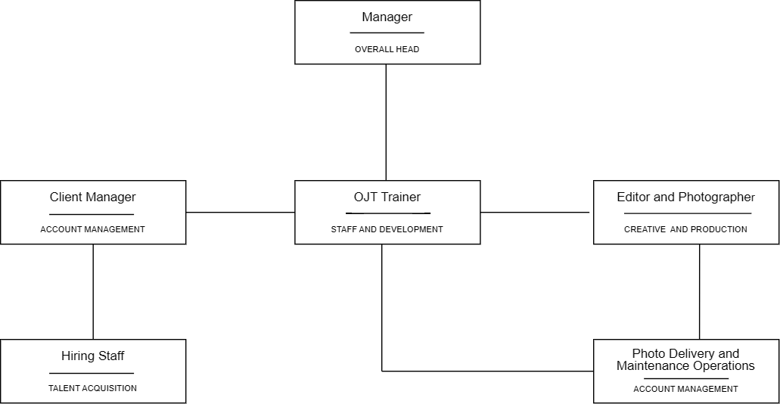
Figure 1

Organizational Chart

Workflow Diagram

This diagram illustrates the workflow of the photography company, showing how responsibilities flow from management to departments, leading to production and final photo delivery.
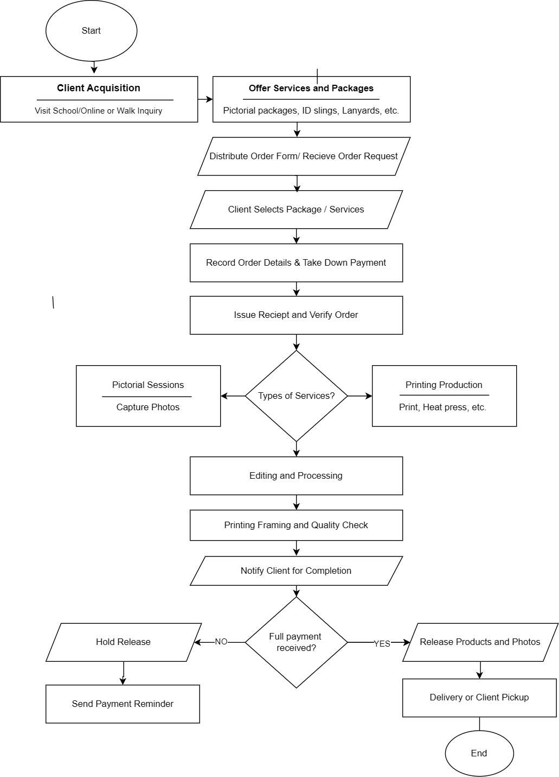
Figure 2
Figure 2

Workflow Diagram

CHAPTER 4

METHODOLOGY, RESULTS, AND DISCUSSIONS

This chapter presents the development methodology, requirements analysis, system design, implementation context, testing approach, and evaluation discussion for E-KODAK. The current deployment at https://ekodakdeployment.netlify.app/ is used as the reference for the customer-facing website. Results are reported only were supported by the manuscript’s recorded evaluation data; no new numerical findings are inferred from the live website.

Development Methodology
This part of the study discusses the various phases of constructing the system as demonstrated in Figure 3. The study utilized the Extreme Programming (XP) model, an agile approach chosen specifically to handle the dynamic and changing workflows of photography studio operations, such as shifting shoot schedules, partial down payments, and custom graduation packages (Beck, 2000). Unlike traditional plan-driven methods or heavier frameworks, XP was selected because it is best suited for small teams that need direct communication, simple design, and rapid small releases (Mahnic, 2012). By building E-KODAK in short iterative cycles with continuous user feedback, the team was able to test functional modules early on live deployments, significantly reducing integration errors and unnecessary rework (Dybå & Dingsøyr, 2008).

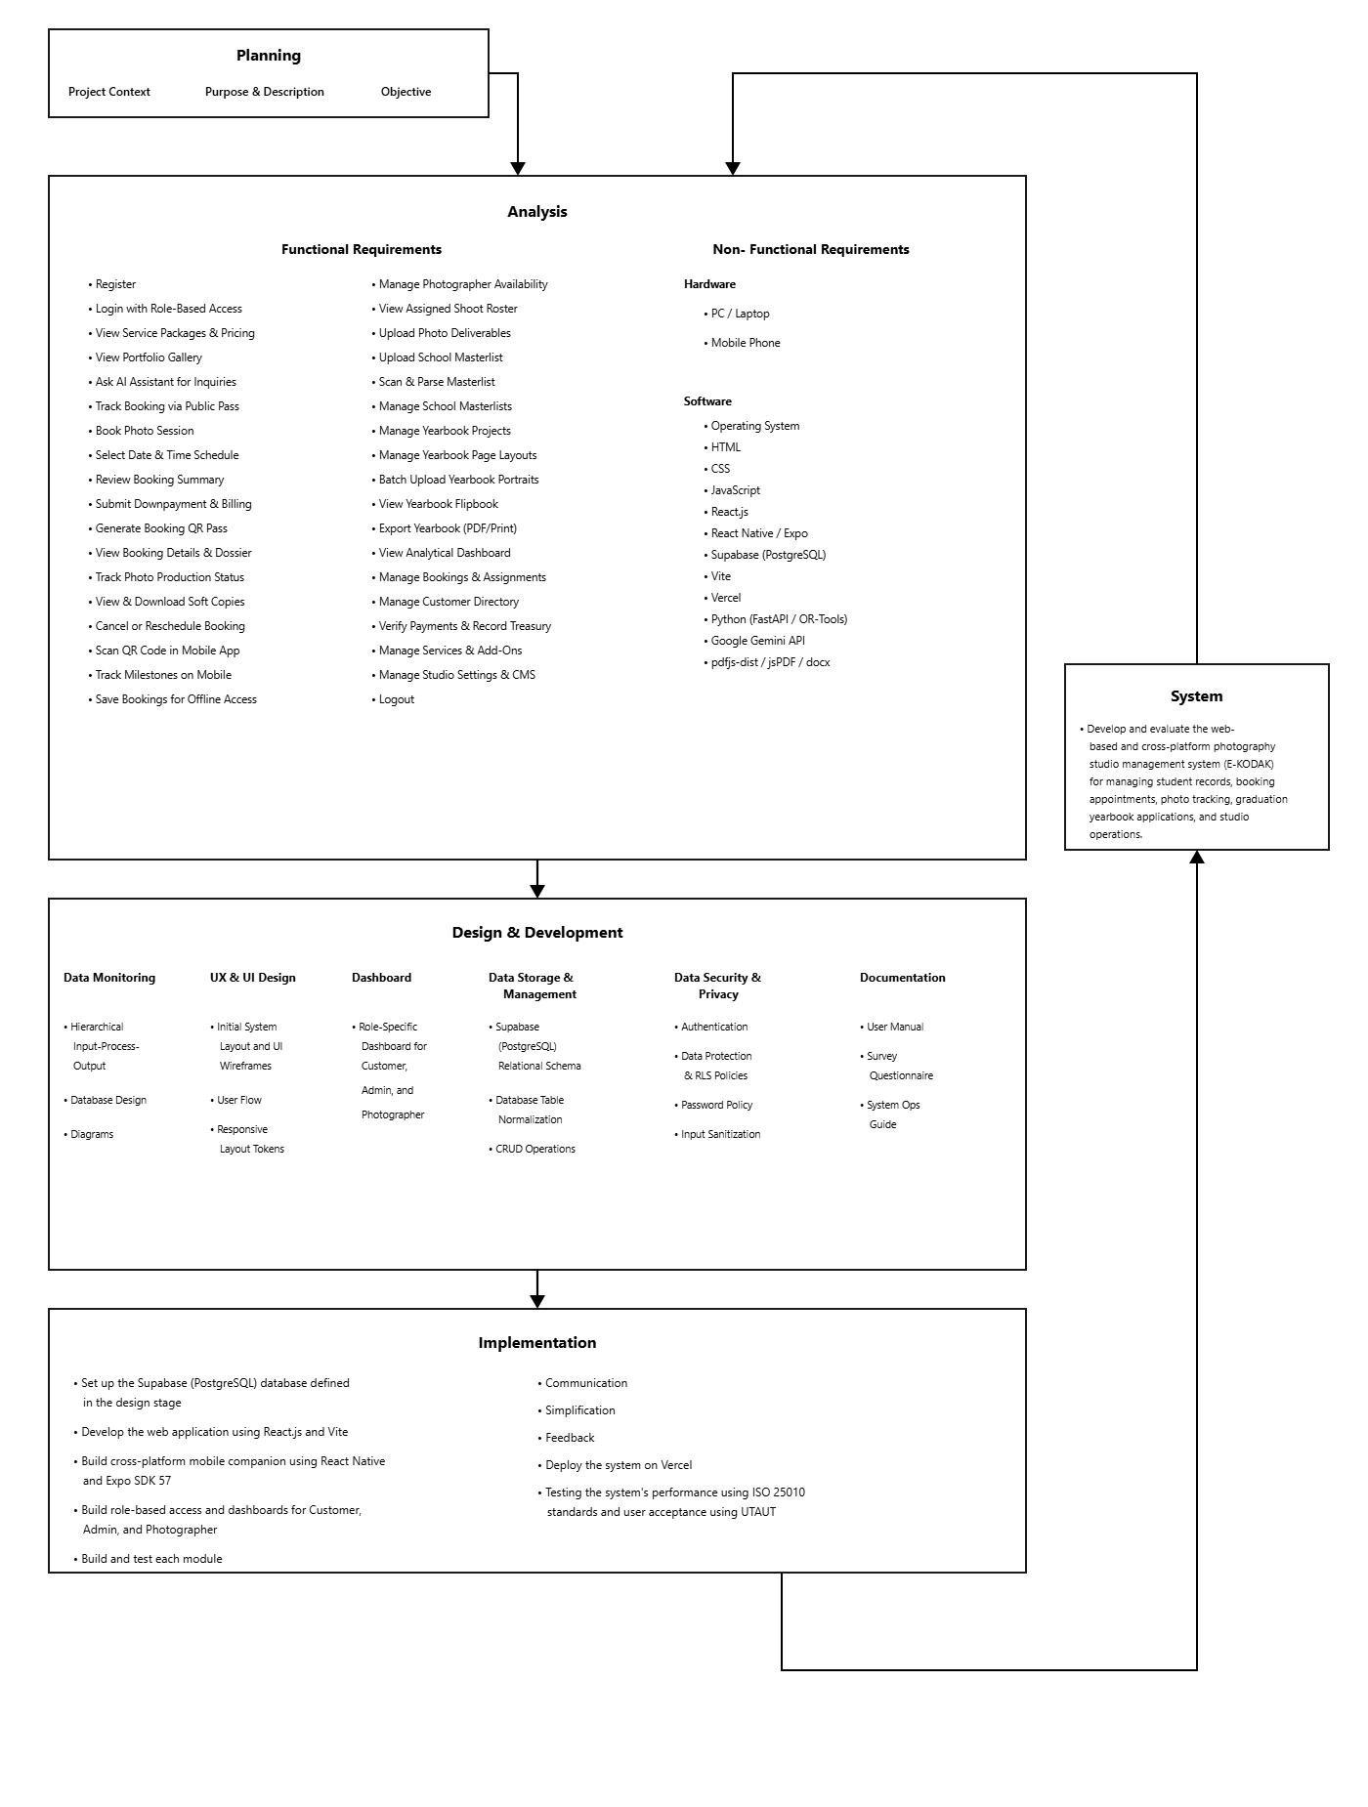

Figure 3

Extreme Programming Language

Requirement Specifications

The proposed system has guidelines to be followed while preparing the software requirement specification. This part includes the project’s functional and non-functional requirements.
Functional Requirements.
This section describes the major functions and procedures that the E-Kodak system must execute to suit the needs of its user which are Admins, Client and Photographer. These features are classified as use cases, with each has describing specific functions such as login, registration, managing user, manage service packages and service pricing, availability, booking appointments, photographer assignments and manage payment.
Additional features including generating payment and transactions through QR code, photo output status, triggers SMS notifications, transaction billing, photo release, transaction records, Manage Yearbook, Upload Yearbook Photos, View Yearbook and finally logging out. Each use case specifies how the system should operate based on each user’s role, ensuring that access and activities are suitable and safe. This may be seen in the table below, which illustrates each use case with its related description for clarity and ease of reference.

Table 1.

Functional Requirements

Use Cases | Description
Use Case No.001 – REGISTER | Enables clients and staff to create an account using their personal and contact details.
Use Case No.002 – LOGIN | Enables users to authenticate securely and access their role-specific portal.
Use Case No.003 – VIEW SERVICE PACKAGES & PRICING | Enables users to browse photography services, package tiers, inclusions, and prices.
Use Case No.004 – VIEW PORTFOLIO GALLERY | Enables users to view categorized studio portfolio photos with an interactive preview modal.
Use Case No.005 – ASK AI ASSISTANT FOR INQUIRIES | Enables clients to ask questions and receive automated answers regarding packages and studio policies.
Use Case No.006 – TRACK BOOKING VIA PUBLIC PASS | Enables clients to check session progress using a booking reference number or public pass link.
Use Case No.007 – BOOK PHOTO SESSION | Enables clients to start a session booking by selecting packages and providing student information.
Use Case No.008 – SELECT DATE & TIME SCHEDULE | Enables clients to view open studio dates and select available session time slots.
Use Case No.009 – REVIEW BOOKING SUMMARY | Enables clients to review service inclusions, pricing breakdowns, and terms before checkout.
Use Case No.010 - SUBMIT DOWNPAYMENT & BILLING | Enables clients to submit downpayments via GCash, Maya, or bank transfer with reference verification.

Use Case No.011 – GENERATE BOOKING QR PASS | Enables the generation of a digital booking pass with a unique QR code upon reservation completion.
Use Case No.012 – VIEW BOOKING DETAILS | Enables clients to view booking details, studio venue maps, and print session credential vouchers.
Use Case No.013 – TRACK PHOTO PRODUCTION STATUS | Enables users to track real-time milestone progress from booking received to ready for pickup.
Use Case No.014 – VIEW & DOWNLOAD SOFT COPIES | Enables clients to view watermarked proofs and download released high-resolution digital photos.
Use Case No.015 – CANCEL OR RESCHEDULE BOOKING | Enables clients to request session rescheduling or cancel reservations according to studio policies.
Use Case No.016 – SCAN QR CODE IN MOBILE APP | Enables users to scan booking QR codes using the mobile app camera to retrieve session details.
Use Case No.017 –TRACK PROGRESS ON MOBILE | Enables mobile users to monitor real-time production stages guided by interactive studio mascots.
Use Case No.018 – SAVE BOOKINGS FOR OFFLINE ACCESS | Enables mobile users to cache and view their session details without an active internet connection.
Use Case No.019 - MANAGE PHOTOGRAPHER AVAILABILITY | Enables photographers to configure working schedules and block off-duty calendar dates.
Use Case No.020 – VIEW ASSIGNED SHOOT | Enables photographers to view their schedule of assigned shoots, client briefs, and session details.
Use Case No. 021- UPLOAD PHOTO DELIVERABLES | Enables photographers to upload captured photo sets by booking directly to the studio vault.
Use Case No. 022- UPLOAD SCHOOL MASTERLIST | Enables clients or the admin to upload class section rosters in PDF or document format.

Use Case No. 023- SCAN & PARSE MASTERLIST | Enables automated extraction of student names, ID numbers, sections, packages, and mottos from documents.
Use Case No. 024- MANAGE SCHOOL MASTERLISTS | Enables the admin to view, edit, and organize uploaded student section rosters.
Use Case No. 025- MANAGE YEARBOOK PROJECTS | Enables the admin to create and configure academic yearbook publication projects.
Use Case No. 026- MANAGE YEARBOOK PAGE LAYOUTS | Enables the admin to select and configure yearbook page templates and design themes.
Use Case No. 027- BATCH UPLOAD YEARBOOK PORTRAITS | Enables the admin to batch upload and link individual 2x2 graduation portraits to student records.
Use Case No. 028- VIEW YEARBOOK FLIPBOOK | Enables users to preview compiled yearbook pages in an interactive 3D digital flipbook format.
Use Case No. 029- EXPORT YEARBOOK (PDF/PRINT) | Enables the admin to run preflight completeness checks and export print-ready yearbook PDF files.
Use Case No. 030- VIEW ANALYTICAL DASHBOARD | Enables the admin to view real-time studio KPIs, booking volumes, and revenue metrics.
Use Case No. 031- MANAGE BOOKINGS & ASSIGNMENTS | Enables the admin to update booking milestones, manage walk-in orders, and assign photographers.
Use Case No. 032- MANAGE CUSTOMER DIRECTORY | Enables the admin to search client academic profiles and monitor live portal presence.
Use Case No. 033- VERIFY PAYMENTS & RECORD TREASURY | Enables the admin to verify payment proofs, record cash receipts, and issue printable vouchers.
Use Case No. 034- MANAGE SERVICES & ADD-ONS | Enables the admin to configure service categories, package tiers, inclusions, and add-on pricing.
Use Case No. 035- MANAGE STUDIO SETTINGS & CMS | Enables the admin to configure operating hours, payment QR codes, policies, and landing page notices.
Use Case No.036 – LOGOUT | Enables users to terminate their active session securely and clear authentication tokens.

Table 1 is essential for defining and organizing the functional requirements of E-KODAK: A Photography Management System with Real Time Tracking. Clarifying these features for the administrators, photographers, and customers ensures strict alignment with operational workflows, streamlines the Extreme Programming development process, and facilitates clear communication among all stakeholders.
Non-Functional Requirements. This section outlines the system's non-functional requirements, specifying the technological architecture, performance expectations, security protocols, and other essential software characteristics required to run the system without simulation. Table 2 below reflects a detailed breakdown.

Table 2

Non-Functional Requirements

Non-Functional Requirements | Description
NonFunc_001 | Personal Computer / Laptop
NonFunc_002 | Mobile Smartphone (Android / iOS)
NonFunc_003 | Operating System
NonFunc_004 | React.js
NonFunc_005 | Tailwind CSS
NonFunc_006 | Vite
NonFunc_007 | React Native/Expo
NonFunc_008 | Supabase (PostgreSQL)
NonFunc_009 | Netlify
NonFunc_010 | Python (FastAPI / OR-Tools)
NonFunc_011 | Google Gemini API
NonFunc_012 | pdfjs-dist / jsPDF / docx

Table 2 highlights the system’s non-functional requirements, providing a clear overview of the tools, technologies, and environments essential for its development and operation. It ensures the technical feasibility of the project, aligning resources and infrastructure with system needs to guarantee smooth implementation and performance.

Hardware and Software Specifications. This portion of non-functional requirements includes the price lists for hardware components and software and their corresponding prices, as reflected in Table 3 and 4.

Table 3

Hardware Specifications

 | Specifications |  | Pricelist
 | Laptop | 8GB RAM | 256GB SSD | WINDOWS 11 |  | ₱ 20,000.00
 | MOBILE PHONE | SAMSUNG Z FLIP 3 | 12GB  RAM | 256GB SSD | ANDROID |  | ₱ 6,500.00
 | MOBILE PHONE | INFINIX GT20 PRO | 24GB |  25GB SSD | ANDROID |  | ₱ 16,999.00

Sources: Acer, Infinix, Samsung

Table 3 specifies the hardware requirements and their corresponding costs, providing a clear guide for procurement. It ensures stakeholders understand the

necessary investments and align resources with the project's hardware needs for smooth implementation and user accessibility.
Table 4

Software Specifications

Name | Price
Premium Antivirus Software | Yearly Subscription | ₱1,200 – ₱2,000
Office Suite | Yearly Subscription | ₱3,500 – ₱4,000
Cloud Storage | Yearly Subscription | ₱1,200 – ₱2,000
Domain Registration | Yearly Subscription | ₱800 – ₱1,500
Web Hosting (PostgreSQL & PHP Support) | Yearly  Subscription | ₱2,500 – ₱4,500
SMS Notification API (e.g., Semaphore) | Prepaid  Credits | ₱500 – ₱1,500
CCTN Fiber | Monthly Subscription | ₱899.00
Sources: Kaspersky/McAfee, Microsoft, Hostinger, Semaphore PH, PLDT Home

Table 4 outlines the software specifications and their associated financial costs, providing a clear breakdown of the essential tools and subscriptions required to deploy E-KODAK:. It helps stakeholders understand the specific software needs such as web hosting, database management, and SMS API integrations alongside the budget allocation for these critical services. This ensures that all technical requirements are securely met within the project's financial and operational framework.

Requirements Analysis

The requirements analysis phase established a detailed understanding of the existing manual workflow at Rafael Orbigoso's Photography Services. It dealt with the system's operational description, technical analysis, and the prioritization of features using the Agile methodology. Thoroughly analyzing these requirements was essential to understanding the distinct expectations of the management, staff, photographers, and clients. This rigorous process ensures that the resulting system perfectly matches the target users' needs for automated booking, real-time tracking, and seamless communication.

Population and Locale of the Study. This portion of the requirements analysis presents the population and locale of the study. The study focuses on modernizing the appointment and operational management system of Rafael Orbigoso's Photography Services, located at 331 Rizal St, West Poblacion, City of Naga, Cebu, through the implementation of integrated architecture, real-time QR tracking, and automated SMS notifications.

It aims to streamline studio workflows, reduce scheduling conflicts, and provide clients with timely updates regarding their photo output statuses. The respondents of this study include the studio manager (administrator), frontline staff (client managers), photographers and editors, and the studio's clients. Data from the studio's historical booking records and daily operations will be utilized to

evaluate transaction efficiency and assess the proposed E-KODAK: system's overall performance.

Population. This portion outlines the study's population. The study's population consists of several stakeholders directly involved in the operation and management of Rafael Orbigoso's Photography Services, located at 331 Rizal St, West Poblacion, City of Naga, Cebu.

The population consists of one studio manager, one client manager, three photographers and editors, one hiring staff and one staff delivery and maintenance operations. Their active involvement in the studio's daily operations and services makes them valuable sources of information.
Their participation is critical in providing valuable insights for reviewing the current manual booking system, analyzing the operational workflow, and identifying the bottlenecks in photo output tracking and client communication.

Locale of the Study. This section covers the study’s location, which focuses on the development and implementation of a photography management system with real-time tracking at Rafael Orbigoso's Photography Services, located at 331 Rizal St, West Poblacion, City of Naga, Cebu.

The researchers selected this studio due to its active engagement in providing diverse photography services and the accessibility of its personnel and

customers, which enables successful data gathering and live system testing. The chosen studio provides a perfect setting for observing current manual operations and determining how centralized database solutions, QR code tracking, and automated SMS notifications might improve operational efficiency and customer satisfaction. Its strategic location allows for regular engagement with the manager, studio employees, and clients, ensuring the successful collection of relevant data. This strategic positioning is shown in Figure 4 on the following page.

Figure 4

Location of Rafael Orbigoso’s Photography Services
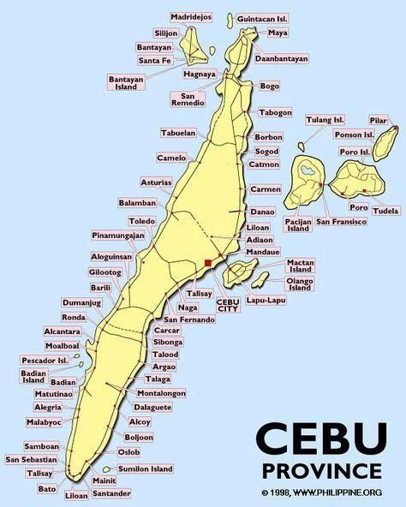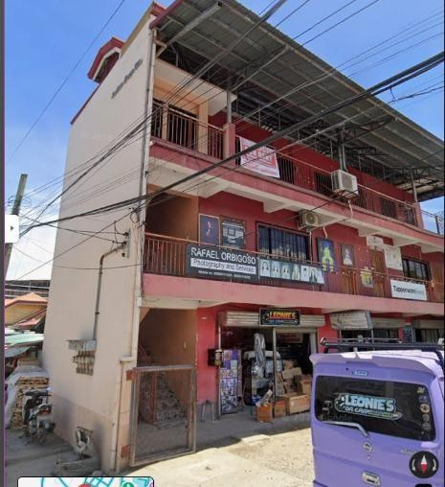

Problem Analysis. This section documents the evaluation, classification, and understanding of the current manual system's limitations at Rafael Orbigoso's Photography Services.

PIECES. This portion of the problem analysis utilizes the PIECES framework, which stands for Performance, Information, Economy, Control/Security, Efficiency, and Services. This structured approach helps identify specific operational bottlenecks in the studio and outlines the corresponding digital opportunities that E-KODAK: will provide. This is presented in Table 5 below.

PIECES | Problems | Opportunities
Performance | Manual booking of photo sessions and tracking output statuses via social media chats is slow and highly prone to scheduling conflicts or double-bookings. | Automate appointment scheduling and implement real-time QR code tracking to ensure fast, reliable, and conflict-free service delivery.
Information | Incomplete or  disorganized client details and payment records due to  scattered physical  logbooks and  fragmented chat histories. | Digitize all transaction records into a centralized database for accurate, consistent, and real-time information retrieval across all devices.
Economy | Financial leaks from uncollected balances and high operational costs related to repetitive manual  paperwork and | Reduce overhead costs and financial errors through an automated billing module and integrated  SMS notifications that

 | communication delays. | eliminate manual follow-ups.
Control / Security | Physical receipts and handwritten logs are highly vulnerable to loss, physical damage, or unauthorized viewing by walk-in clients. | Implement role-based access control and secure server-side database storage to ensure data safety, privacy, and controlled system oversight.
Efficiency | Time-consuming retrieval of a specific client's transaction status and the manual updating of  photographers' availability. | Implement instant QR code scanning to retrieve records in seconds and deploy a centralized scheduling calendar for maximum operational efficiency.
Service | Staff members spend excessive time  answering routine client inquiries about photo readiness, taking time away from actual studio  production. | Provide a streamlined, system with automated SMS status updates to drastically improve proactive customer service and client satisfaction.

Table 5

PIECES Evaluation Framework

Cause and Effect Analysis. Table 6 details the cause and effect of the current manual system at Rafael Orbigoso's Photography Services. Specifically, it outlines the existing operational problems, their negative effects on the studio's workflow, the proposed objectives of the E-KODAK: system to resolve them, and the potential constraints during implementation.
Table 6

Cause and Effect Analysis

Problem and  Opportunities | Cause and Effect | System  Objectives | System  Constraints
Manual appointment and transaction record management | Manual handling using physical logbooks leads to scheduling conflicts, double bookings, lost physical receipts, and inefficient studio workflow. | To automate appointment schedu transaction record handling using centralized database improved organization operational efficiency. | Limited technical training for frontline staff and potential resistance to transitioning from familiar paper logs to a digital interface.
Inefficient tracking of photo output statuses. | Relying on manual checks makes it difficult to monitor the exact production stage of a project (e.g.,  Capture, Editing,  Printing), causing delivery delays. | To implement forecasting tools that help predict and prevent seasonal illnesses in animals. | Requires functional hardware  (mobile phones/scanners) and strict staff compliance to update the system at every workflow stage.

Inconsistent client communication and updates. | Clients are not proactively informed when their photos are ready, leading  to excessive inquiries and wasted staff time  managing social media chats. | To provide automated SMS notifications that instantly alert clients regarding their  booking confirmation, payment status, and final photo release. | Reliance on stable internet connectivity (PLDT Fiber) to trigger the API, ongoing costs of SMS credits, and data privacy concerns  regarding client  mobile numbers.
Lack of consolidated data for business analytics. | The absence of digitized historical records prevents management from accurately assessing daily  revenue, popular service packages, and  operational  bottlenecks. | To deploy a high complexity  analytical dashboard that  visualizes business performance and transaction data in real-time for better decision-making. | High code complexity requires rigorous maintenance, and migrating years of historical data from handwritten logs may be incomplete or inaccurate.

Design of Software Systems, Products, and/or Processes

In this part of the capstone project, the researchers elaborate on the architectural structure, system design, and operational processes of E-KODAK: through various visual diagrams. These diagrams are utilized to comprehensively demonstrate the functions, data flows, and web-mobile capabilities of the proposed system.

Hierarchical Input-Process-Output (HIPO). To understand the system's design, its product, and the project process, the researchers created a Hierarchical Input Process-Output (HIPO) diagram that states the function to be accomplished. This diagram is presented in Figure 5 on the next page. It illustrates the flow of data through three main stages: input, process, and output, offering a clear and organized view of how the system's modules function. Each module, such as user

authentication, appointment booking, payment management, QR code generation, photo output status tracking, SMS notification triggering, and analytical reporting, is broken down to show what data is entered, how it is processed such as storing in a centralized database, validating credentials, or decoding QR strings, and what output is generated, such as unique QR graphics, SMS text alerts, or dashboard visualizations. This structured and clear diagram allows everyone to better grasp how the system operates. It demonstrates each function step by step and ensures it meets user needs. Additionally, it serves as a valuable tool during development by clarifying how processes are interconnected and how data flows to produce accurate and relevant results.

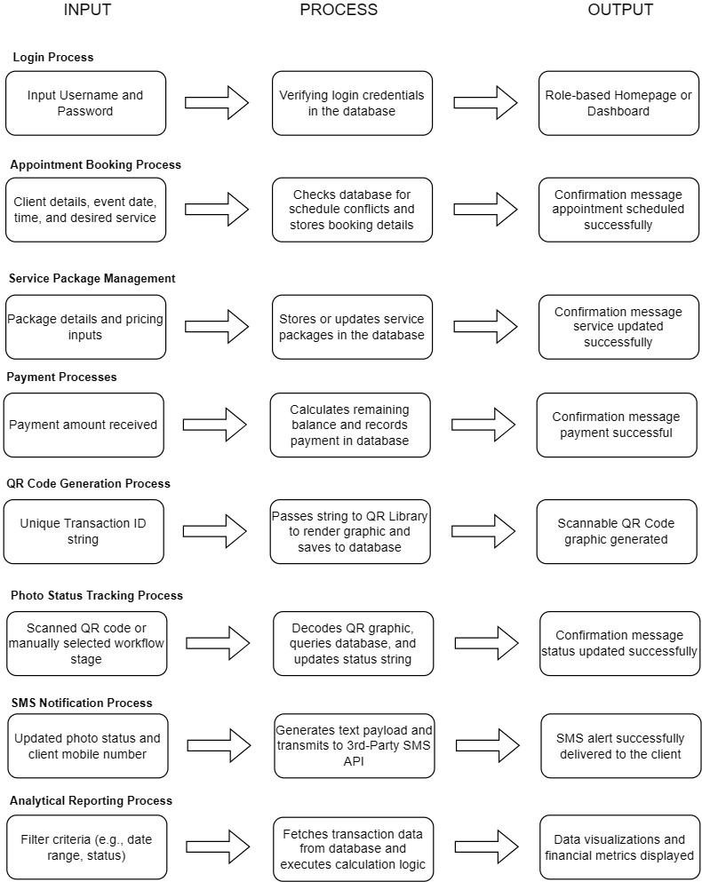

Figure 5

Hierarchical Input-Process-Output

Entity Relationship Diagram. The Entity Relationship Diagram (ERD) is a diagram that explains the entities, or the different roles used within the system. It represents the relationships among various entities, and each entity is defined by its attributes, as shown in Figure 6 below.
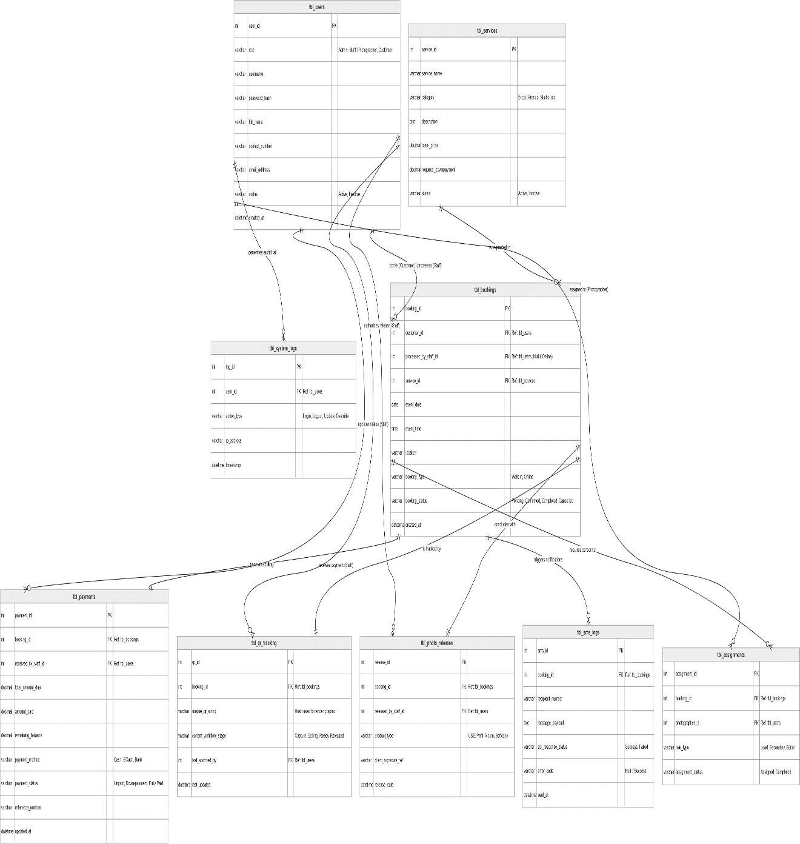

Figure 6

Entity Relationship Diagram

Use Case Diagram. This portion presents the system’s use case diagram for end-users, as shown in the figure below.
Figure 7. Illustrates the Admin's key functions, which involve overseeing the overarching business logic and system-wide data. These capabilities include managing user accounts and role-based access, configuring photography service packages and down-payment pricing, viewing the master transaction records, and monitoring studio performance through a high-complexity analytical dashboard.

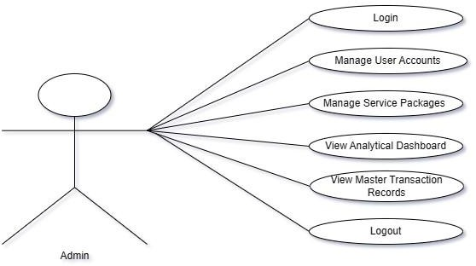
Figure 7

Use Case Diagram for Admin

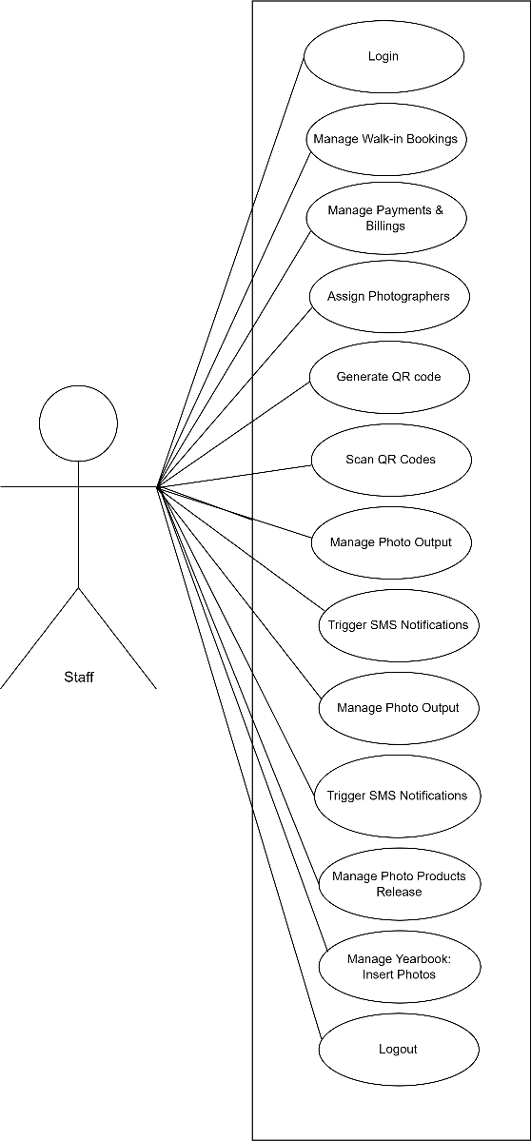
Figure 8 illustrates the Staff's key functions acting as the studio's frontline operators. Their operational capabilities involve managing walk-in bookings, processing down-payments and final transaction billing, generating and scanning transaction QR codes, assigning available photographers to schedules, triggering automated SMS notifications, and formally managing the final photo/product release.

Figure 8

Use Case Diagram for Staff

Figure 9 illustrates the Photographer and Editor's streamlined functions. To maintain secure financial data and prevent system clutter, their access is strictly focused on studio production tasks, specifically viewing their assigned event schedules and updating the workflow photo output status of their current projects.

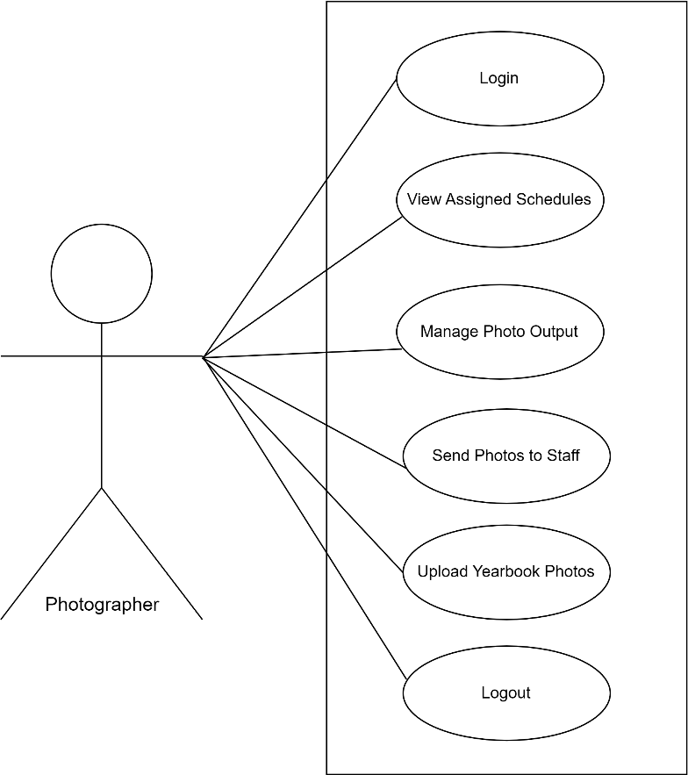

Figure 9

Use Case Diagram for Photographer and Editor

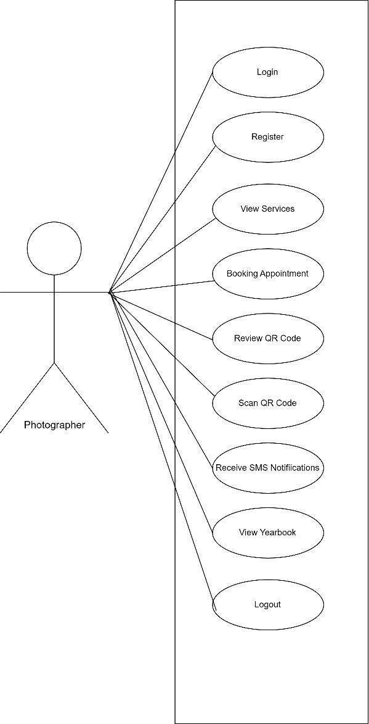
Figure 10 illustrates the Customer's key functions for online interaction and self-service. These capabilities include secure self-registration, viewing available photography service packages, booking online appointments, receiving their dynamically generated transaction QR code, and scanning it to independently track their photo production status.

Figure 10

Use Case Diagram for Customer

Flowchart of the Proposed System. This portion of the software system design presents the flowchart of the proposed system, as shown in the figure.

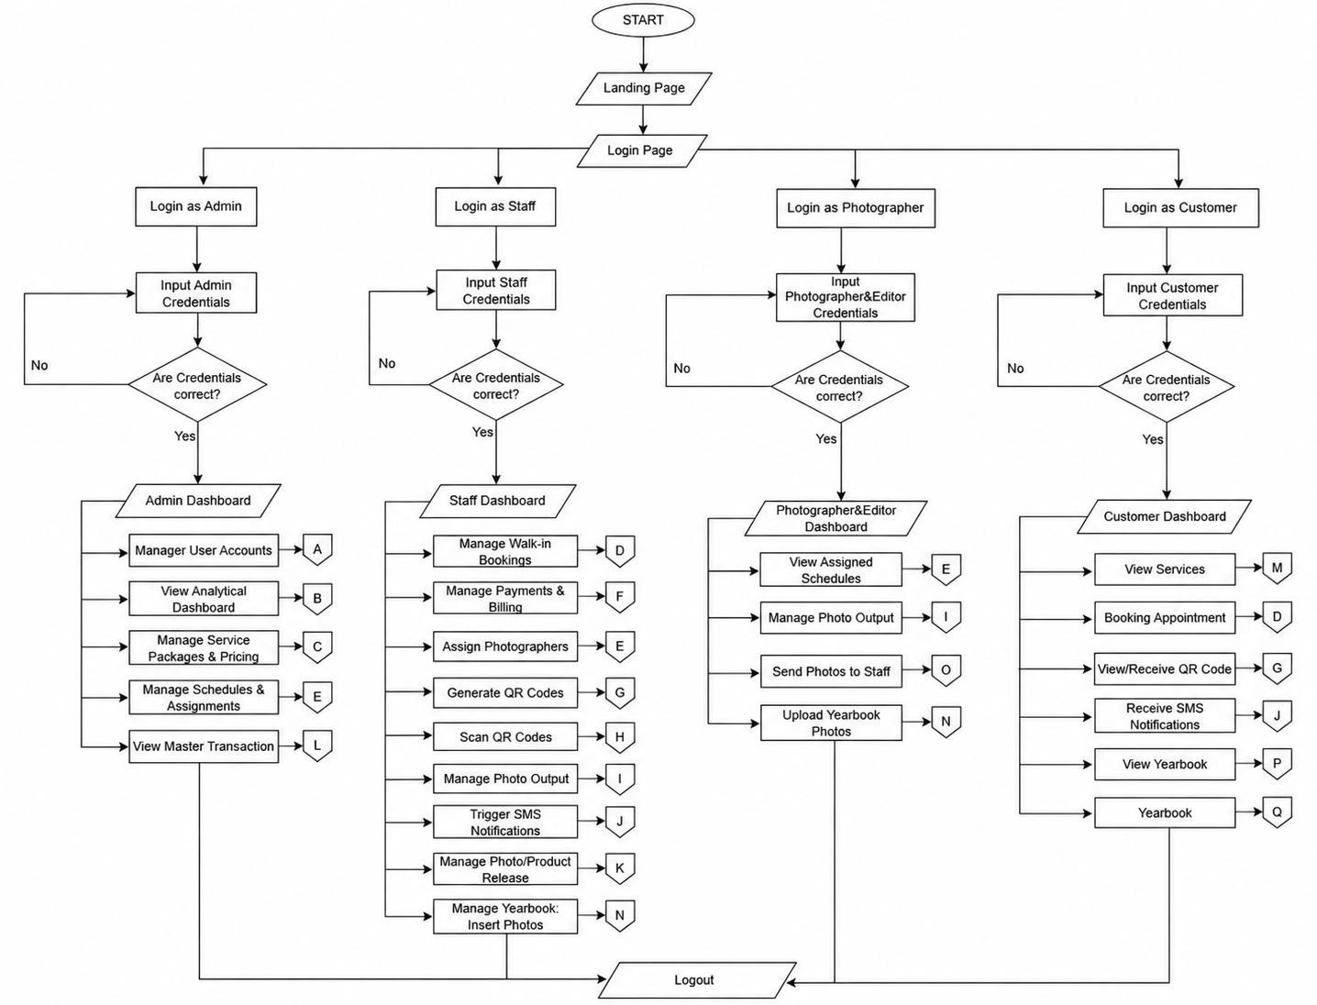
Figure 11

Flowchart of the proposed system

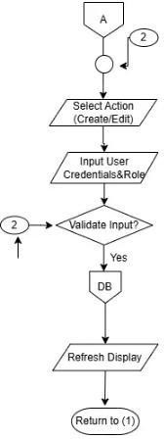

Figure 12

Flowchart of the proposed system – Continuation A

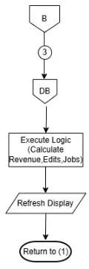

Figure 13

Flowchart of the proposed system – Continuation B

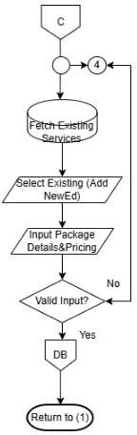

Figure 14

Flowchart of the proposed system - Continuation C

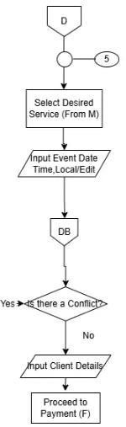

Figure 15
Flowchart of the proposed system – Continuation D

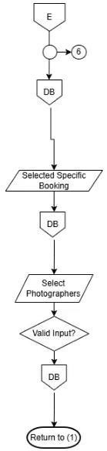

Figure 16
Flowchart of the proposed system – Continuation E

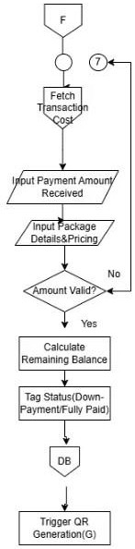

Figure 17

Flowchart of the proposed system – Continuation F

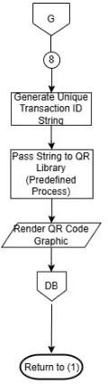

Figure 18

Flowchart of the proposed system – Continuation G

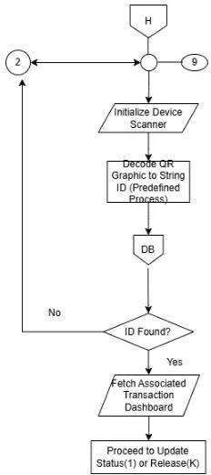

Figure 19

Flowchart of the proposed system – Continuation H

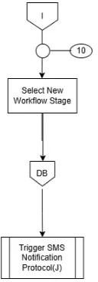

Figure 20

Flowchart of the proposed system – Continuation I

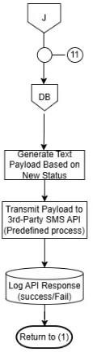

Figure 21

Flowchart of the proposed system – Continuation J

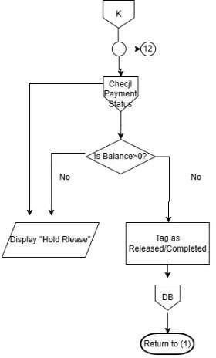

Figure 22

Flowchart of the proposed system – Continuation K

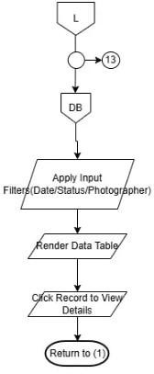

Figure 23

Flowchart of the proposed system – Continuation L

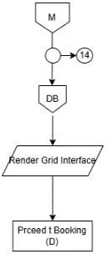

Figure 24

Flowchart of the proposed system – Continuation M

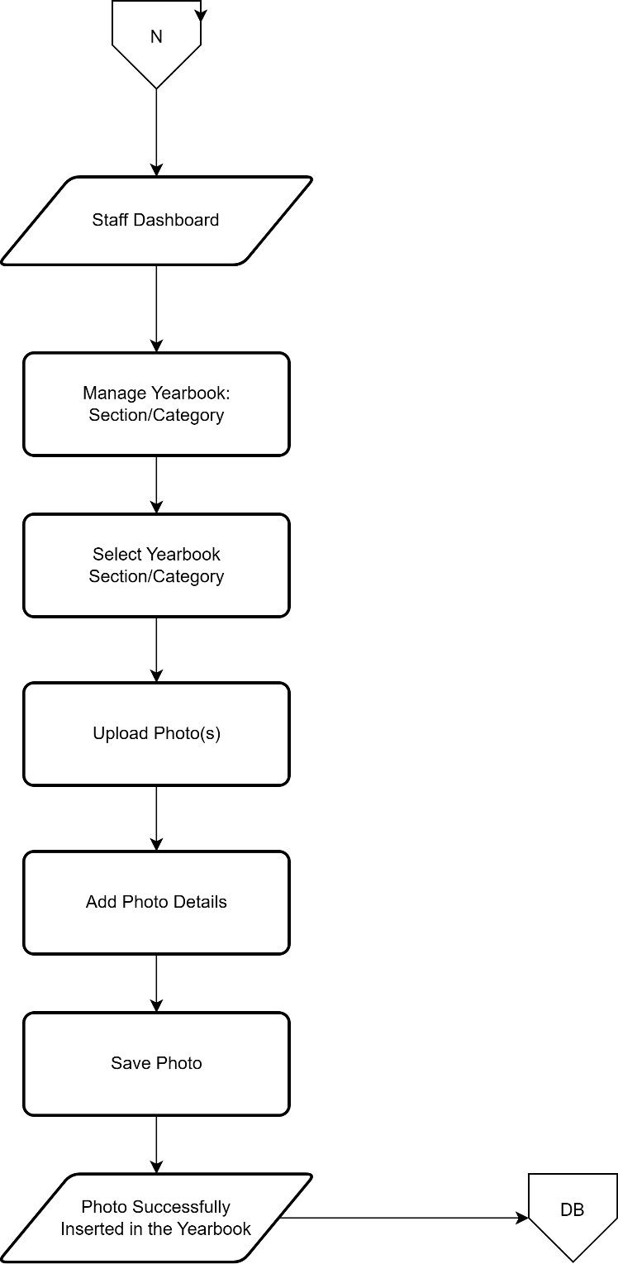

Figure 25

Flowchart of the proposed system – Continuation N

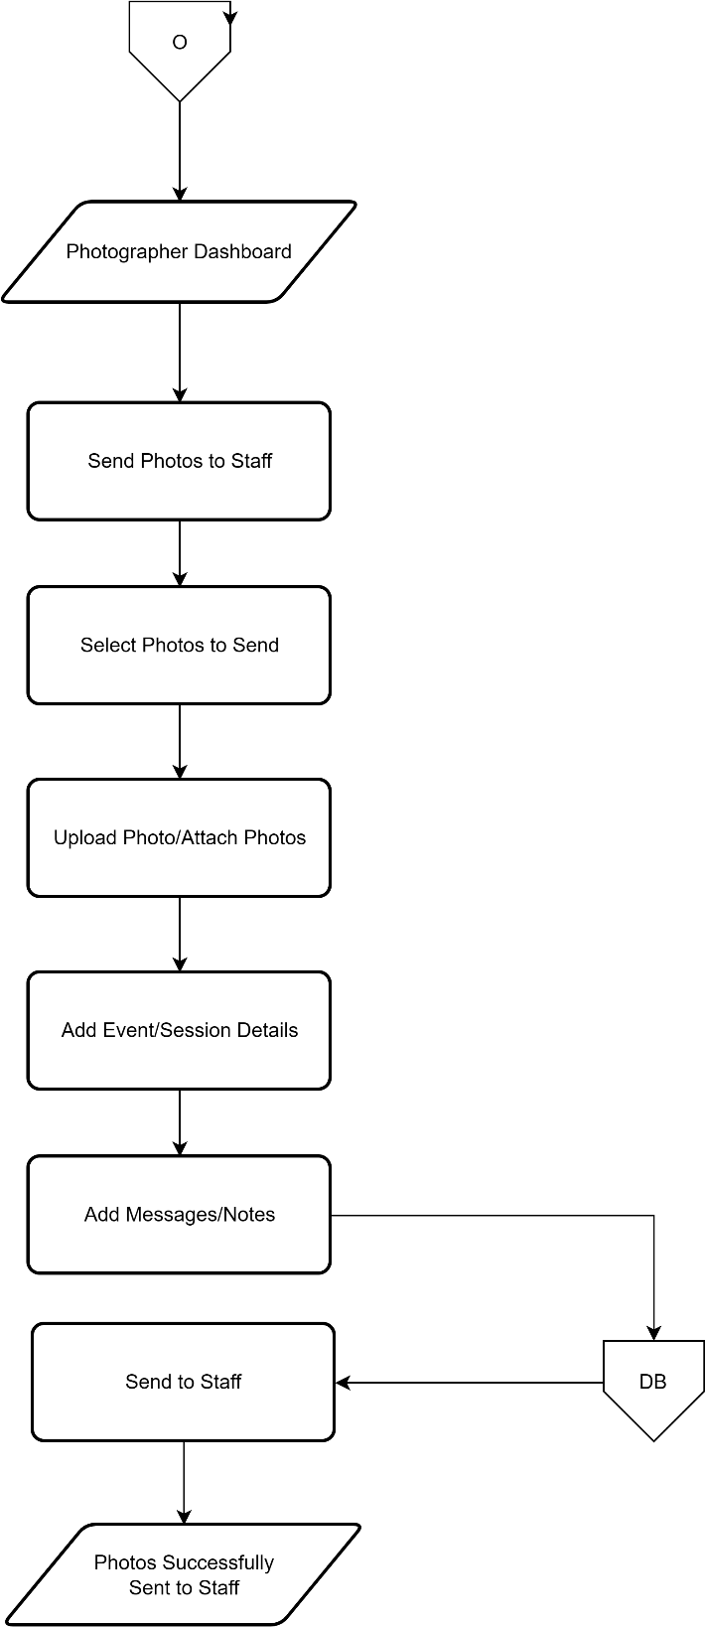

Figure 25

Flowchart of the proposed system – Continuation O

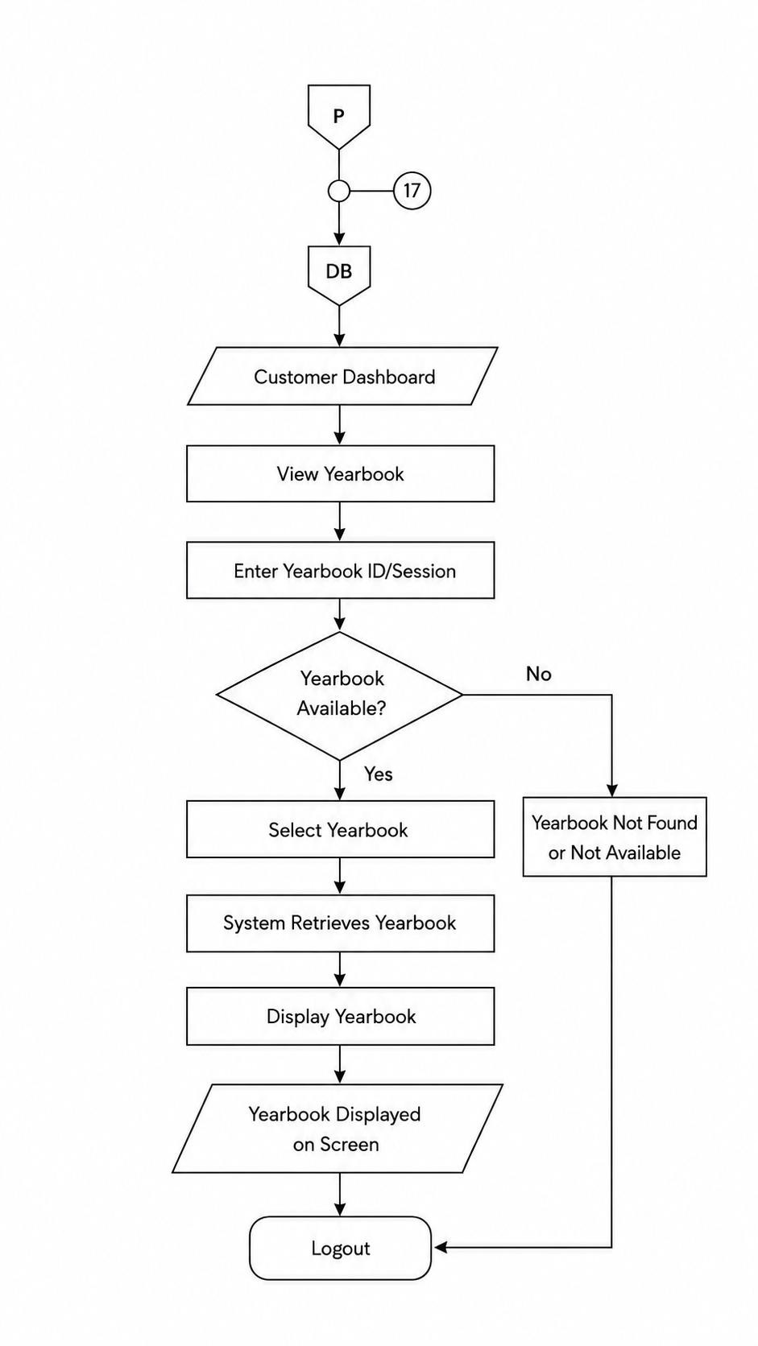
Figure 27

Flowchart of the proposed system – Continuation P

System Evaluation
The researchers assessed the system performance to confirm it’s adherence to the ISO 25010 Standards.
The deployment aimed to build, test, and deliver services to the users specified by service design. The goal was to deploy releases into operation and establish effective use of the service to deliver value to the users.
System evaluation was the assessment of the overall system. Thirty-seven (37) respondents were given the opportunity to test E-KODAK and complete the prepared evaluation instrument. Their responses were collected and interpreted using the five-point scale presented below.
SCALE PARAMETERS VERBAL INTERPRETATION
5 4.21 - 5.00 Strongly Agree (SA)
4 3.41 - 4.20 Agree (A)
3 2.61 - 3.40 Neutral (N)
2 1.81 - 2.60 Disagree (D)
1 1.00 - 1.80 Strongly Disagree (SD)
The respondents rated the system's performance on a scale of 1 to 5, with 5 being the highest or Strongly Agree and 1 being the lowest with a verbal interpretation of Strongly Disagree.

Distribution of Respondents. The evaluation instrument was answered by 37 respondents. Based on the respondent categories recorded in the survey, the participants consisted of 29 Student/Clients, 4 E-KODAK Personnel/Staff, 1 Photographer, and 3 respondents classified as Others. The distribution is presented in Table 1.
Table 1
Distribution of Respondents

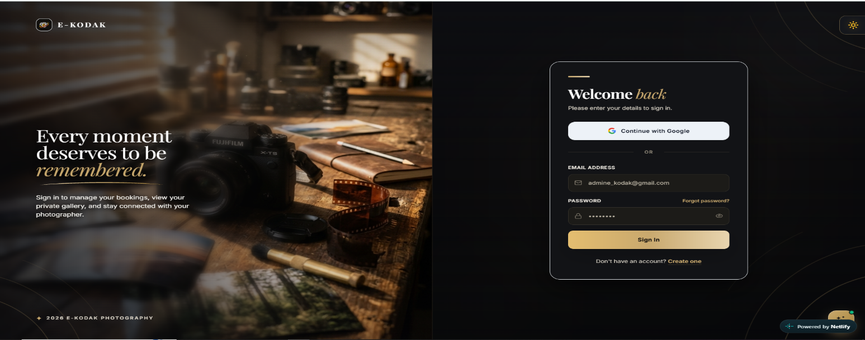
Figure 28
Login Page
This figure shows the E-KODAK login page, where registered users can enter their account credentials to access the system.

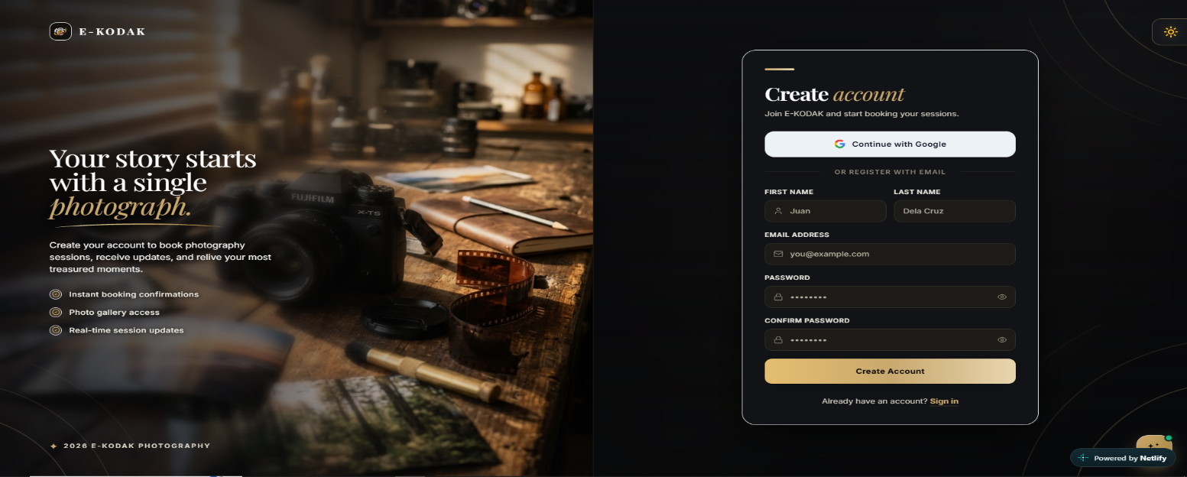

Figure 29
User Registration Page
This figure presents the registration form where new users provide the required information to create an account.
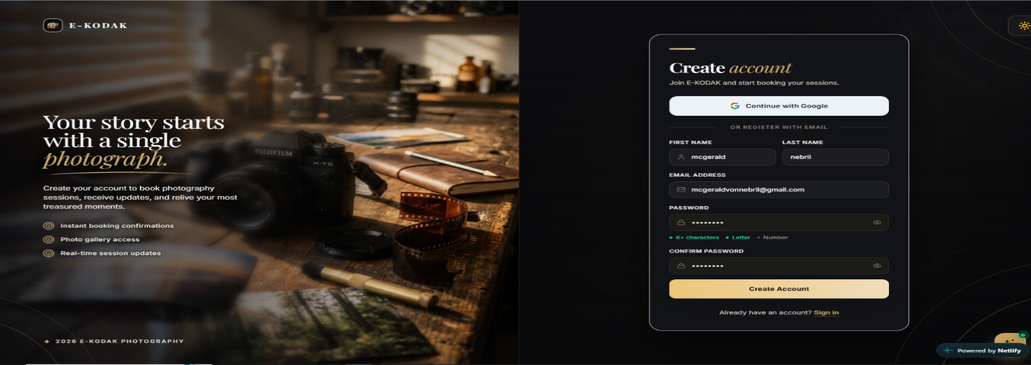

Figure 30
Registration Form with User Information
This figure shows the registration form with user details entered before account creation.

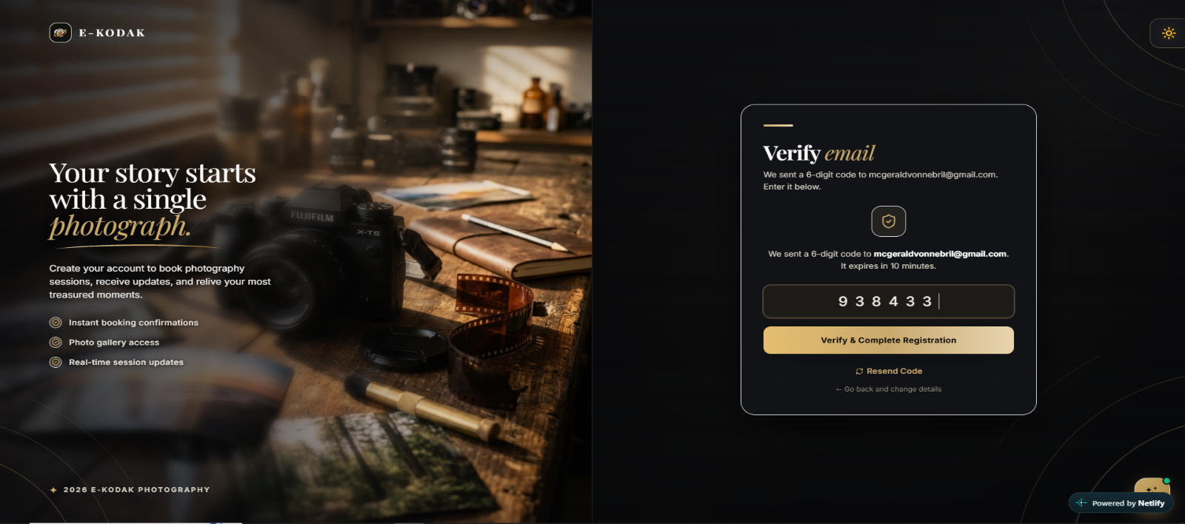
Figure 31
Email Verification Page
This figure displays the email verification interface, where users enter a verification code to confirm their email address.
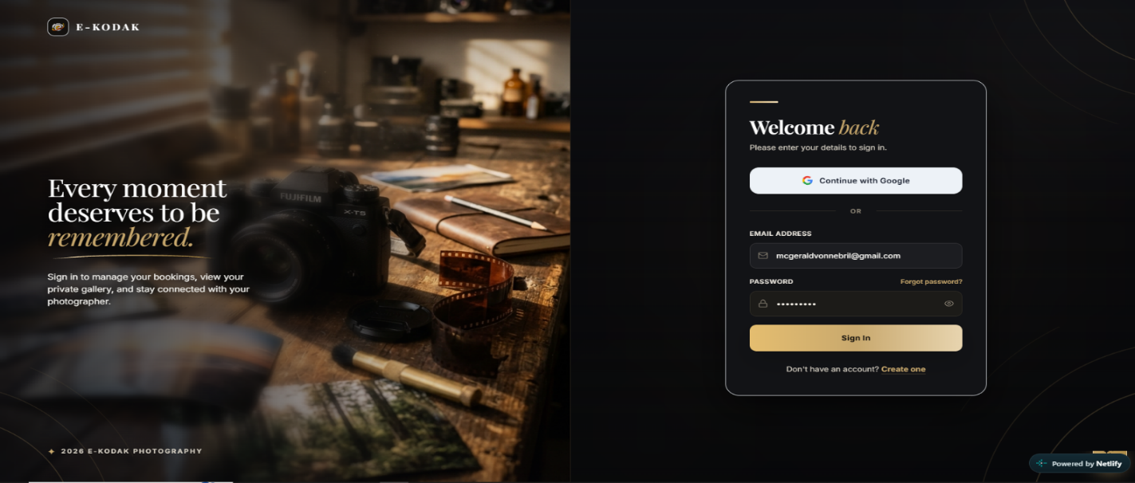
Figure 32
User Login Interface
This figure shows the login interface that allows existing users to access their E-KODAK accounts.
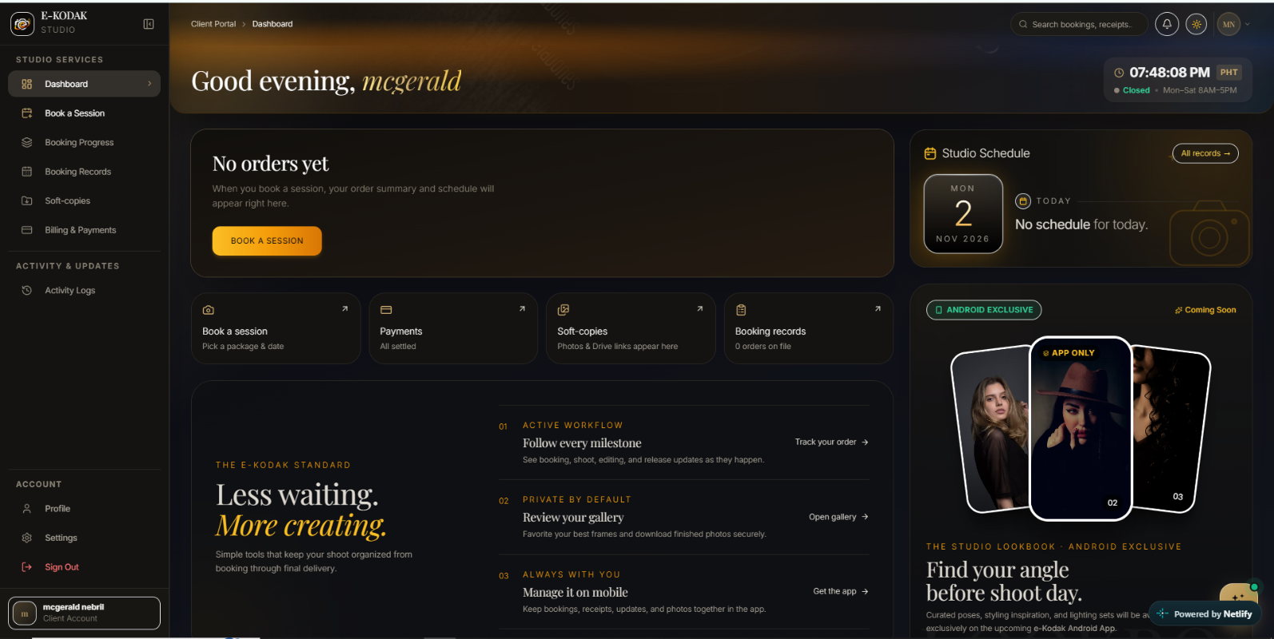

Figure 33
Customer Dashboard
This figure presents the customer dashboard, which provides an overview of the user's activity and available system information.
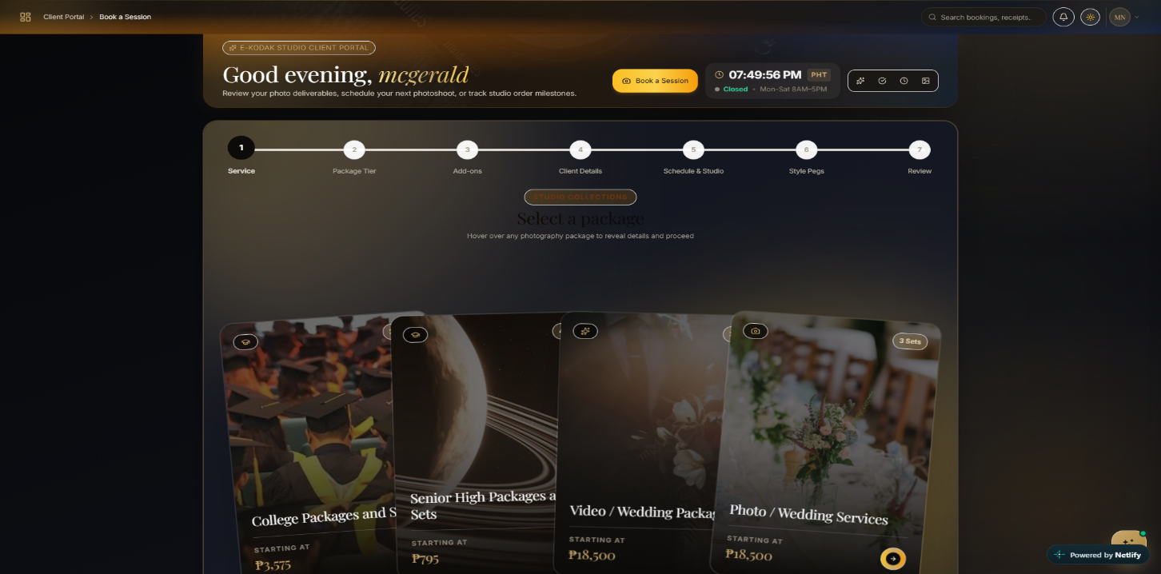

Figure 34
Photography Package Selection
This figure displays the available photography packages that customers can browse when preparing to book a session.
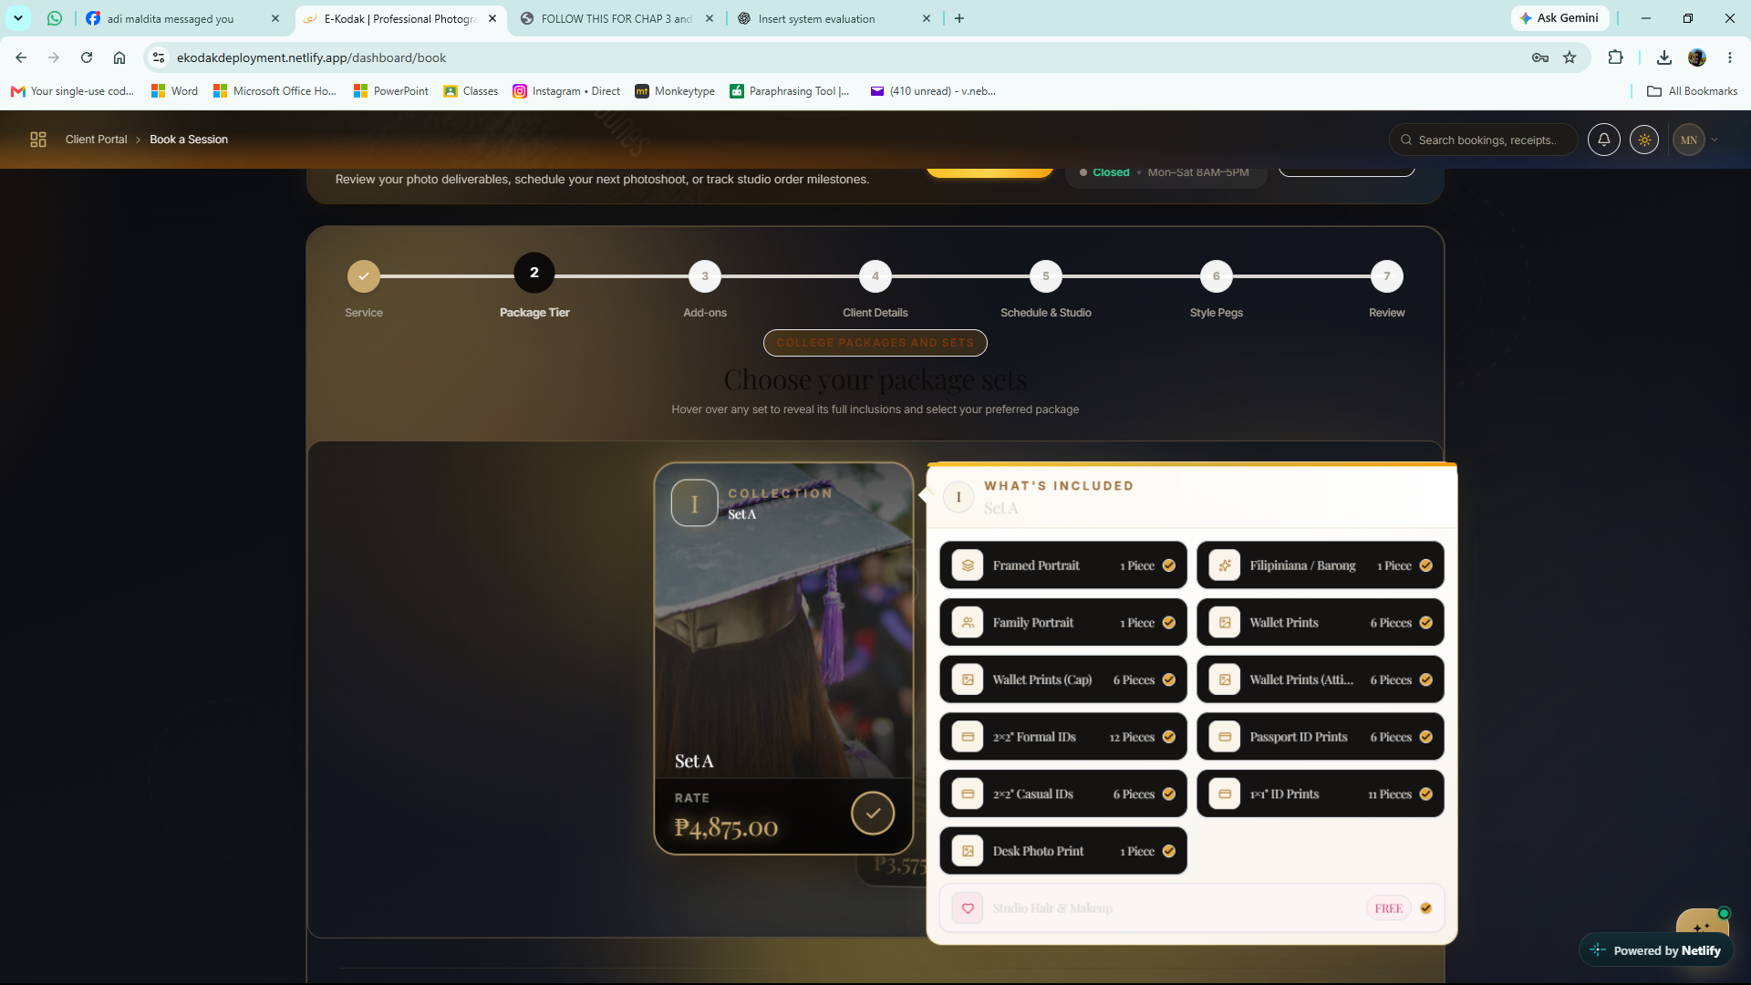

Figure 35
Photography Package Selection
This figure shows the E-KODAK package selection interface, where customers can choose a photography package and review its price and included items before proceeding with their online booking.

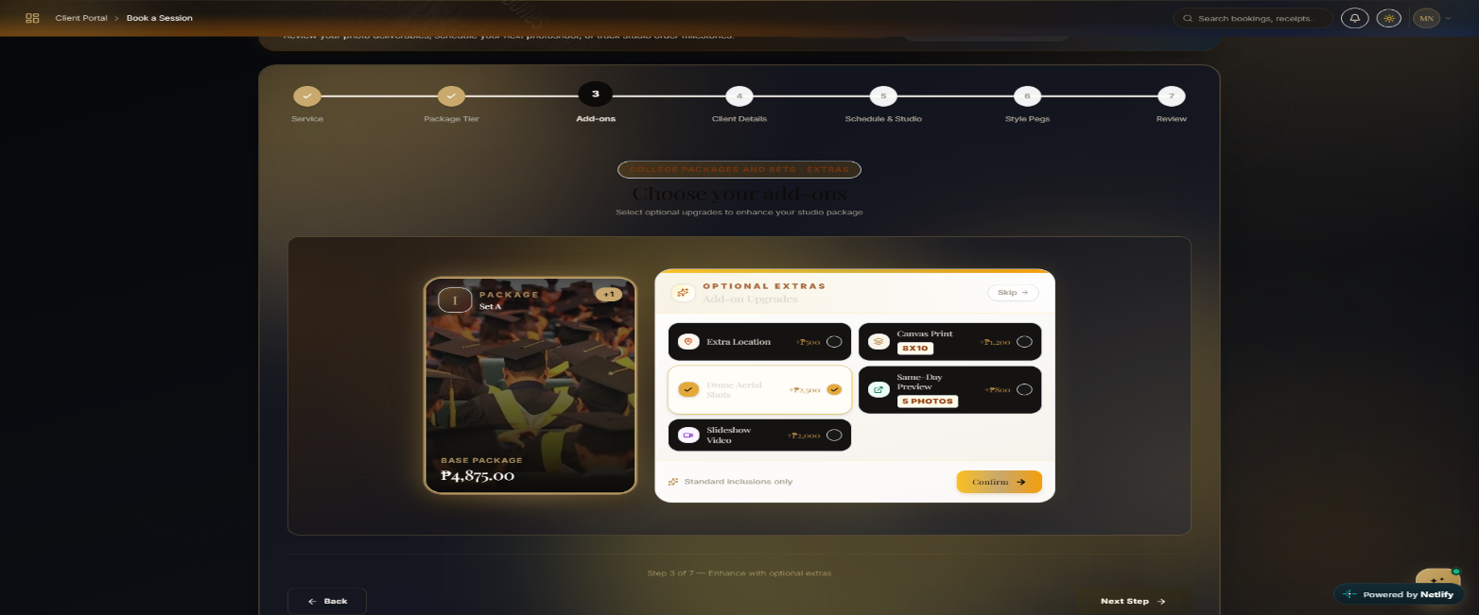
Figure 36
Package Details and Selection
This figure shows the package selection interface, where customers can review the displayed package details and available options.
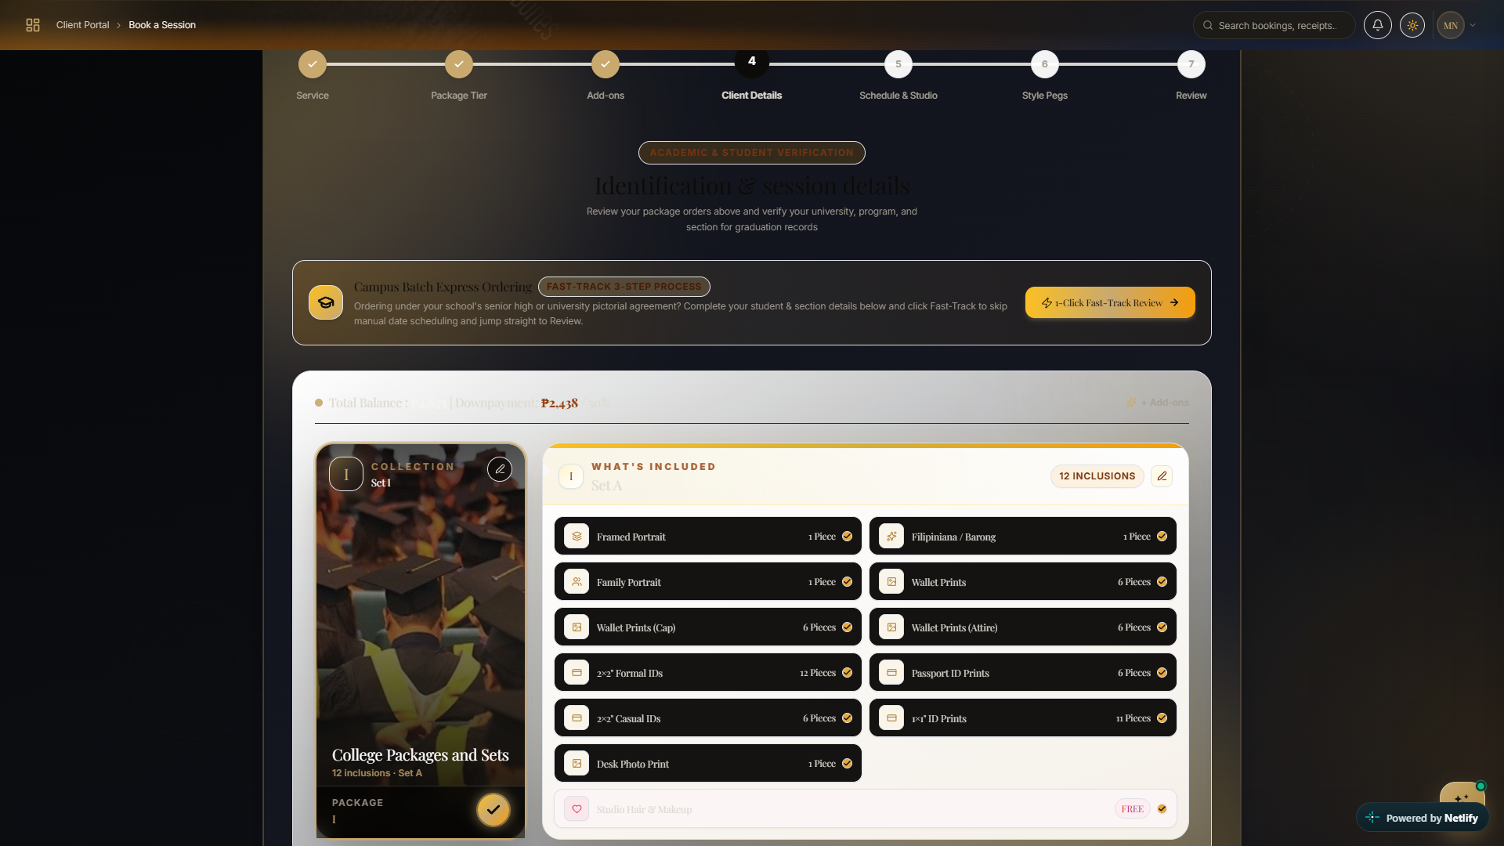

Figure 37
Photography Package and Student Information Form
This figure shows the E-KODAK booking interface, where customers review their selected photography package and enter student information, school details, degree program, graduating batch, and other required details to complete their booking.

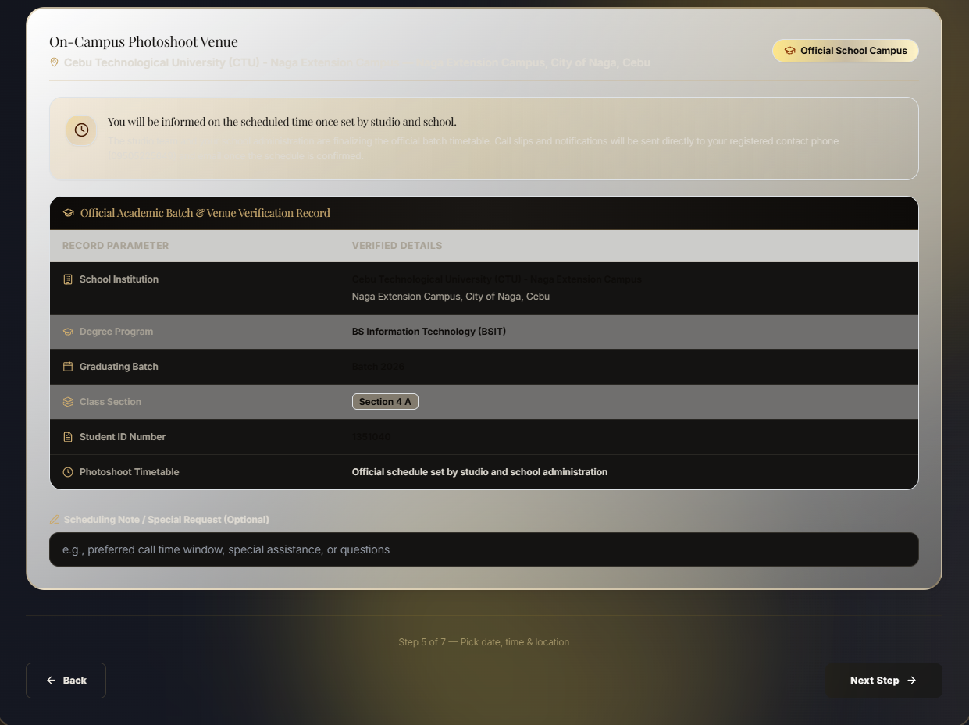

Figure 38
Booking Requirements Interface
This figure presents the booking-related form or requirements table, allowing users to review or select the displayed options.

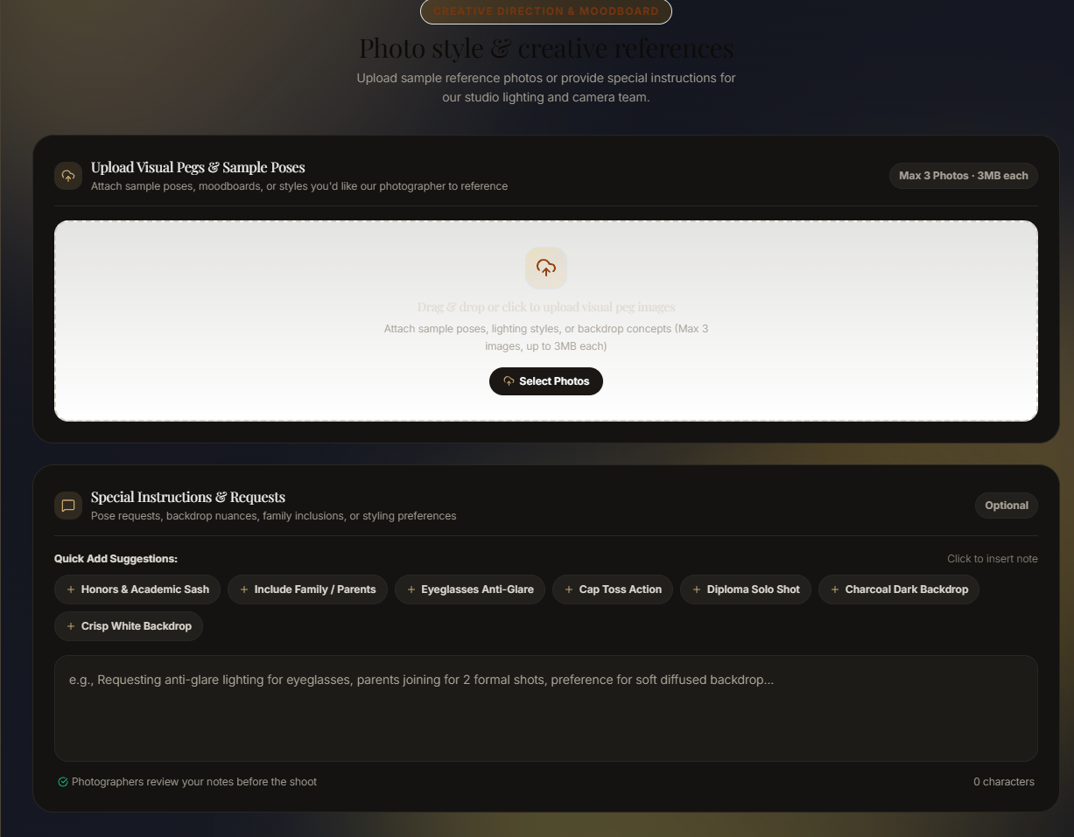

Figure 39
Photo and File Upload Interface
This figure shows the file upload section and related requirements for submitting or managing photography-related files.
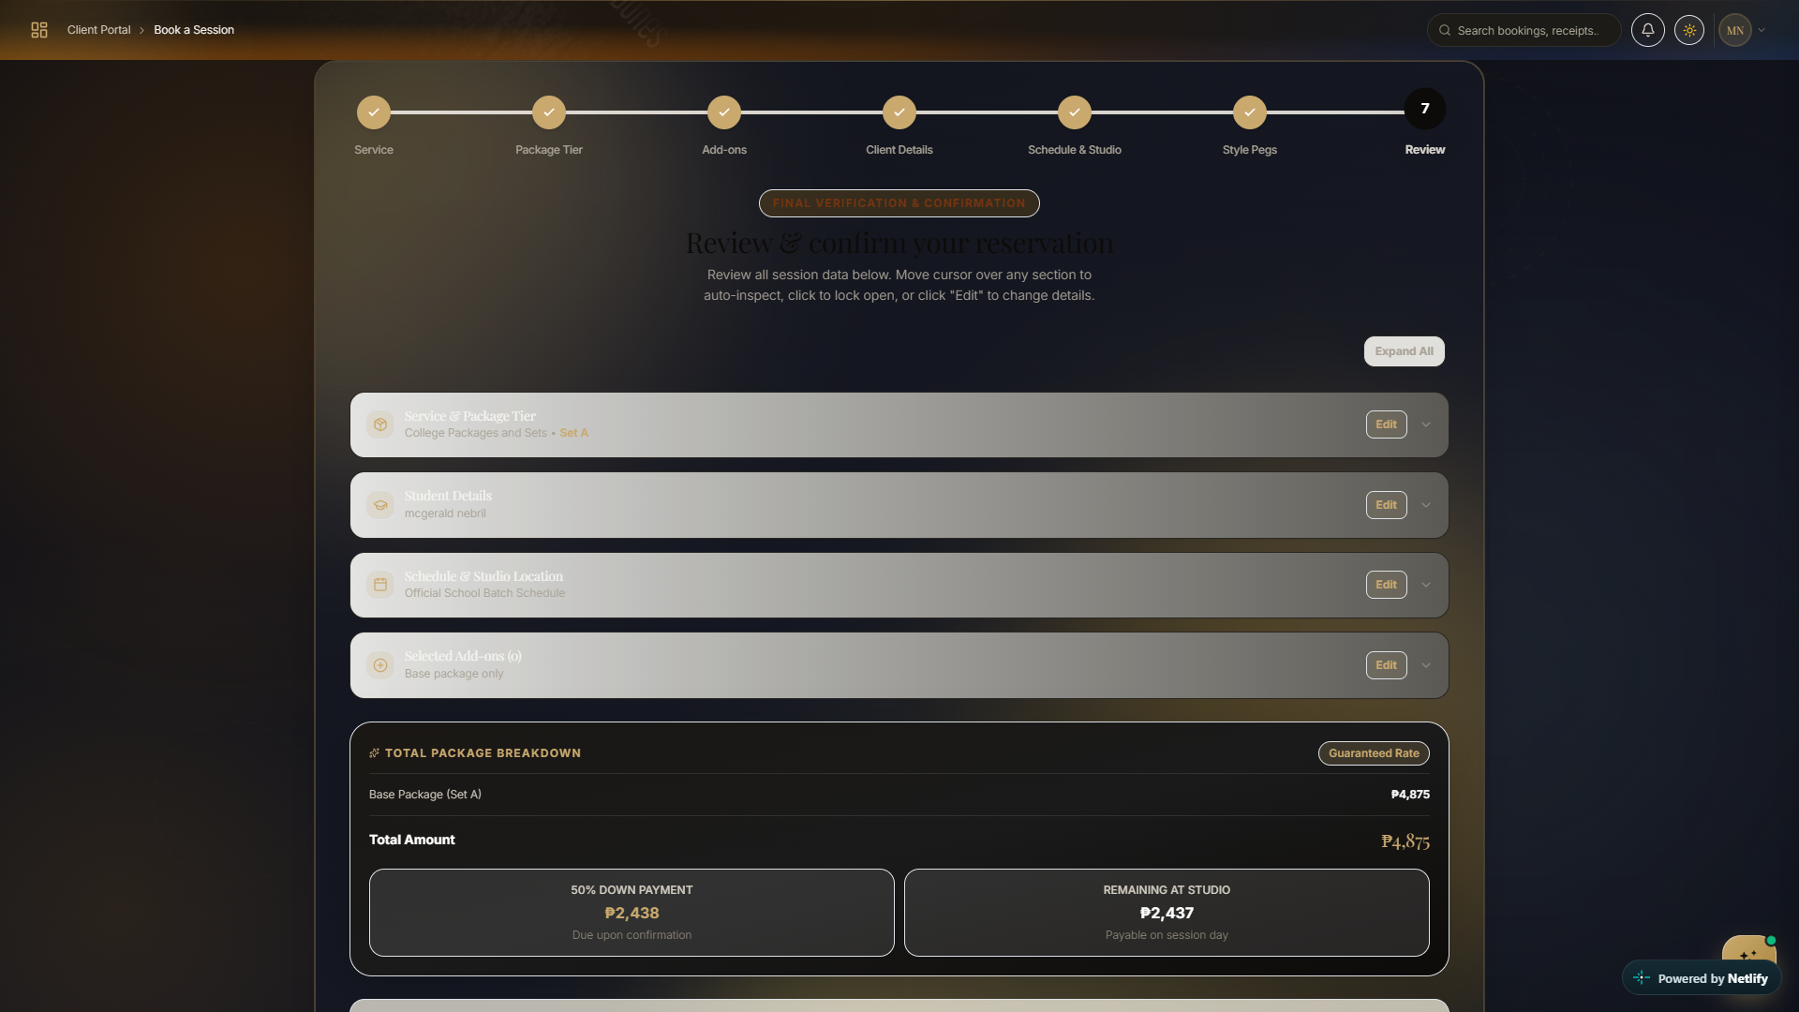

Figure 40
Booking Review and Confirmation
This figure shows the final review page of the E-KODAK system, where customers verify their booking details, selected package, schedule, and add-ons. It also displays the total package cost, down payment, and remaining balance before confirming the reservation.

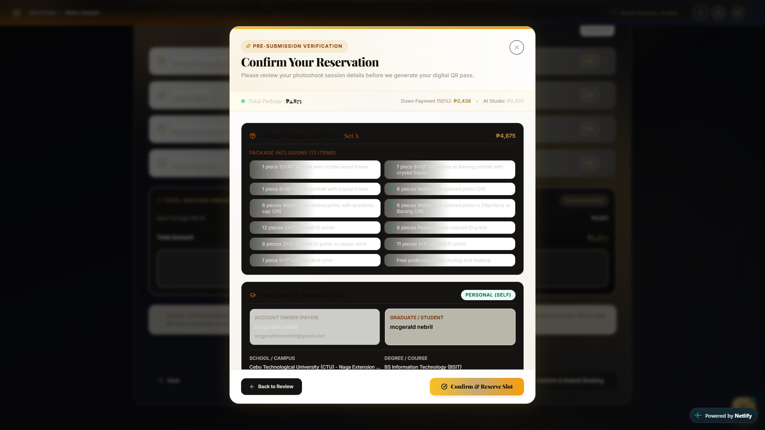

Figure 41
Reservation Confirmation
This figure shows the reservation confirmation window, where customers review their selected photography package, included services, participant information, and payment details before confirming their booking slot.
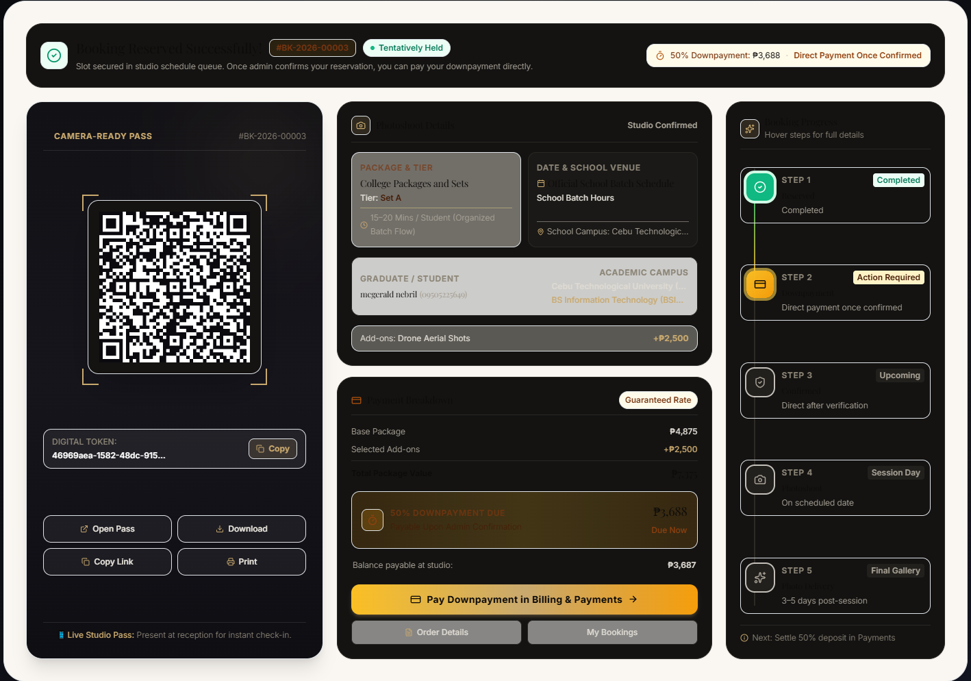
Figure 42
Booking Details and QR Code
This figure displays booking or session information alongside a QR code and related status details.

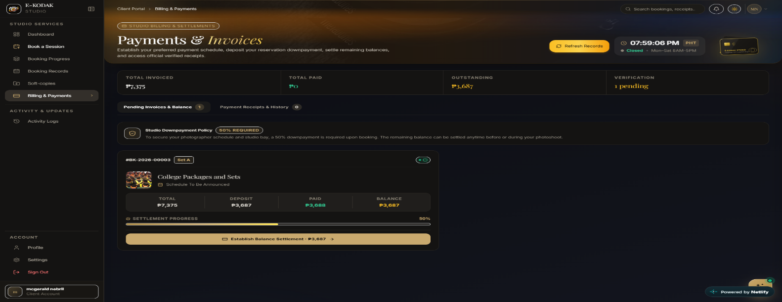

Figure 43
Payments and Invoices
This figure presents the payment and invoice interface, where users can view the displayed billing information.

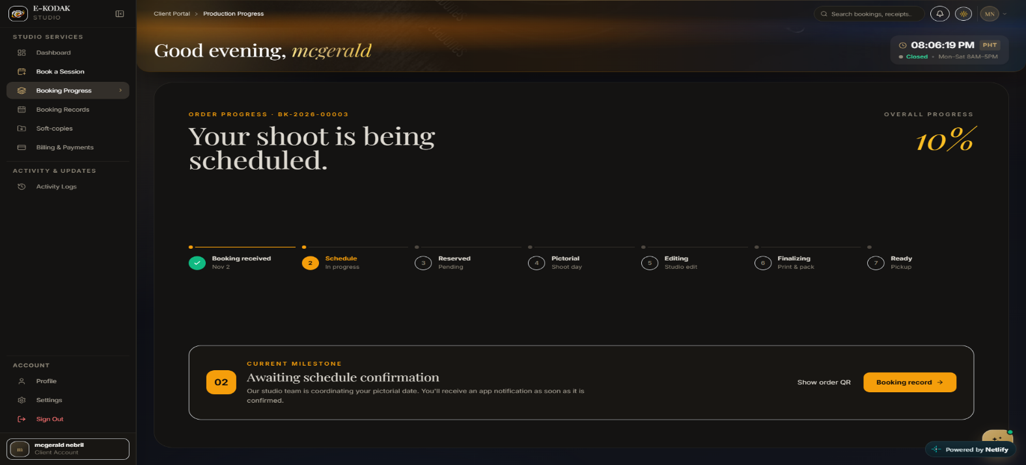

Figure 44
Booking Schedule and Progress
This figure displays the booking status, scheduled photography session, and progress information.

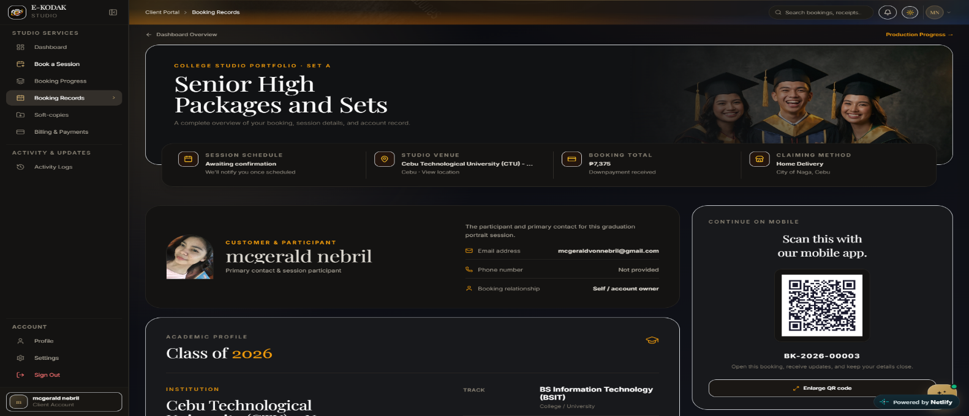

Figure 45
Photography Packages
This figure shows the available photography packages and sets intended for senior high school clients.

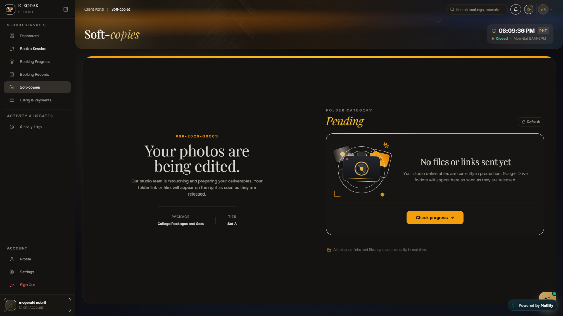

Figure 46
Soft Copies and Photo Editing Status
This figure shows the status of photo editing and soft-copy delivery, indicating whether edited photos or links have been provided.

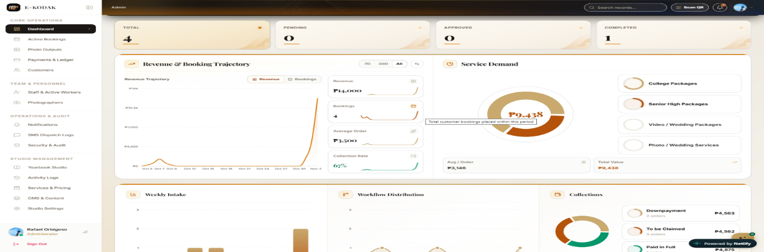

Figure 47
Admin Dashboard
This figure shows the E-KODAK admin dashboard, which displays booking statistics, revenue, service demand, payment collections, and booking records. It allows the administrator to monitor reservations, track photography production progress, and manage customer bookings and payments.

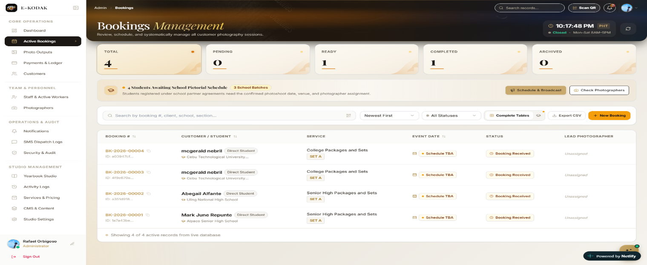

Figure 48
Active Bookings
This figure shows the E-KODAK booking management interface, where the administrator can monitor reservations, view booking statuses, check customer and school information, and manage photography schedules and photographer assignments.

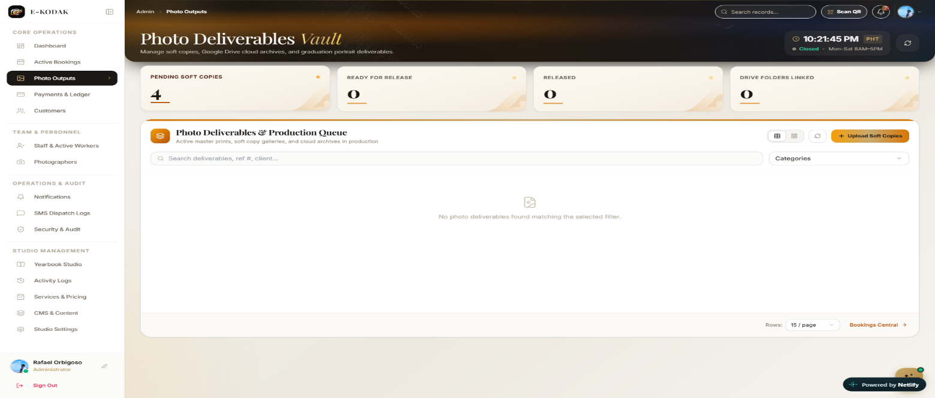
Figure 49
Photo Outputs

This figure shows the E-KODAK photo deliverables interface, where the administrator can monitor pending soft copies, track photo release status, manage digital photo outputs, and upload soft copies for customers.

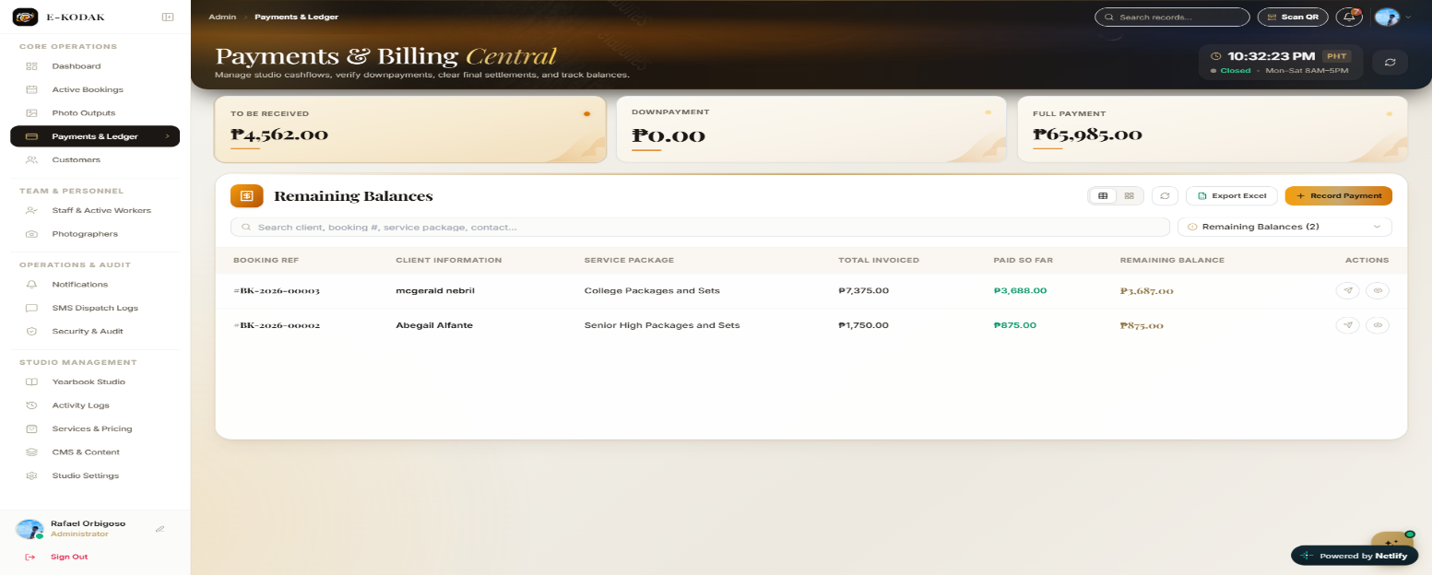
Figure 50
Payments&Ledger

This figure shows the E-KODAK Payments and Billing page, which allows the administrator to monitor customer payments, downpayments, and remaining balances for photography bookings.

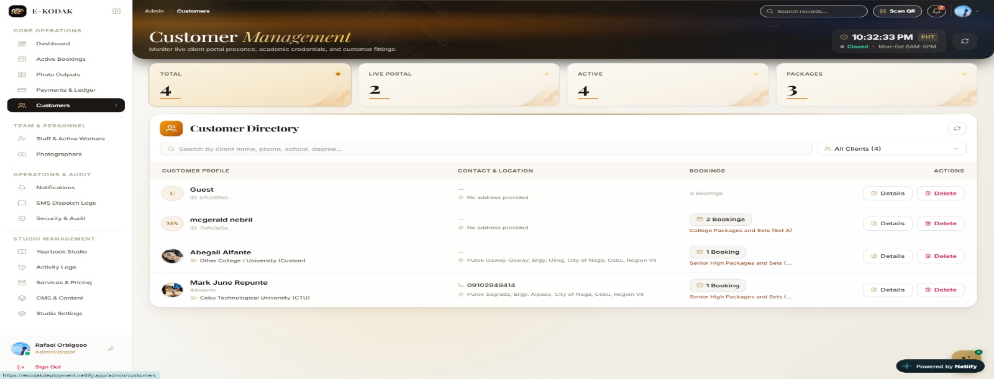
Figure 51
Customers

This figure presents the Customer Management page, where the administrator can view customer profiles, contact information, booking records, and available actions for managing customer accounts.

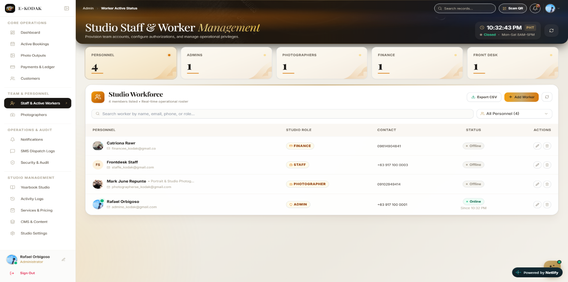
Figure 52
Staff and Worker Management

This figure shows the Studio Workforce page, which allows the administrator to manage staff accounts, assign studio roles, and monitor personnel status.

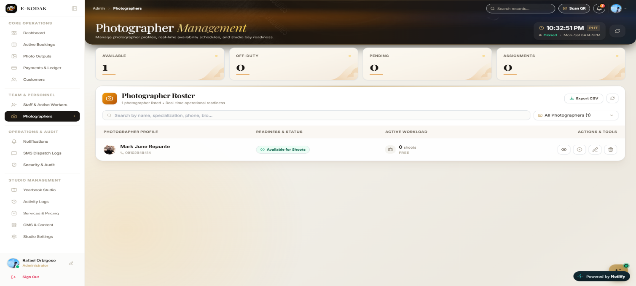
Figure 53
Photographers
This figure presents the Photographer Management page, where the administrator can view photographer profiles, check availability, and monitor their current workload.

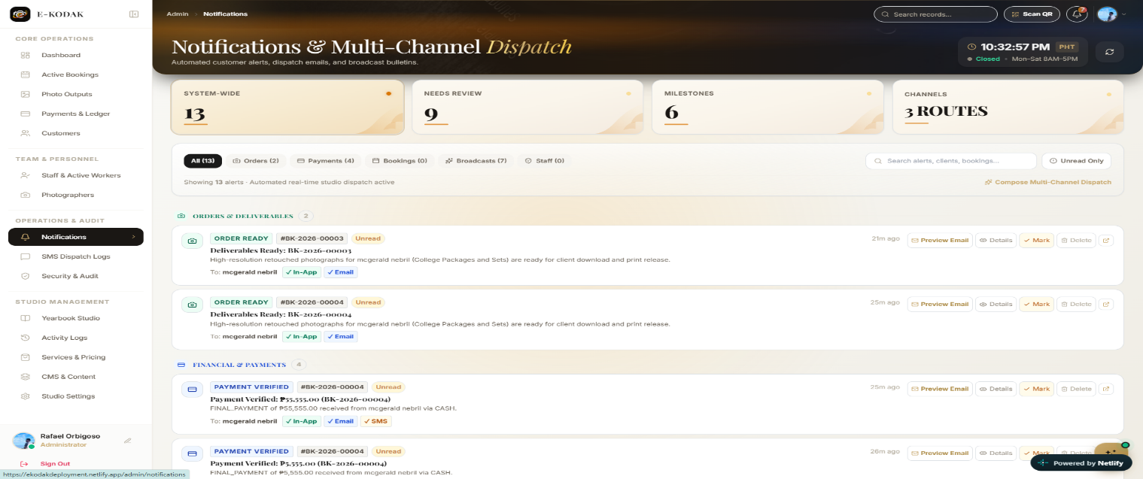
Figure 54
Notifications

This figure shows the Notifications page, where the administrator can monitor booking and payment alerts, review notification details, and manage messages sent through available channels such as in-app notifications, email, and SMS.

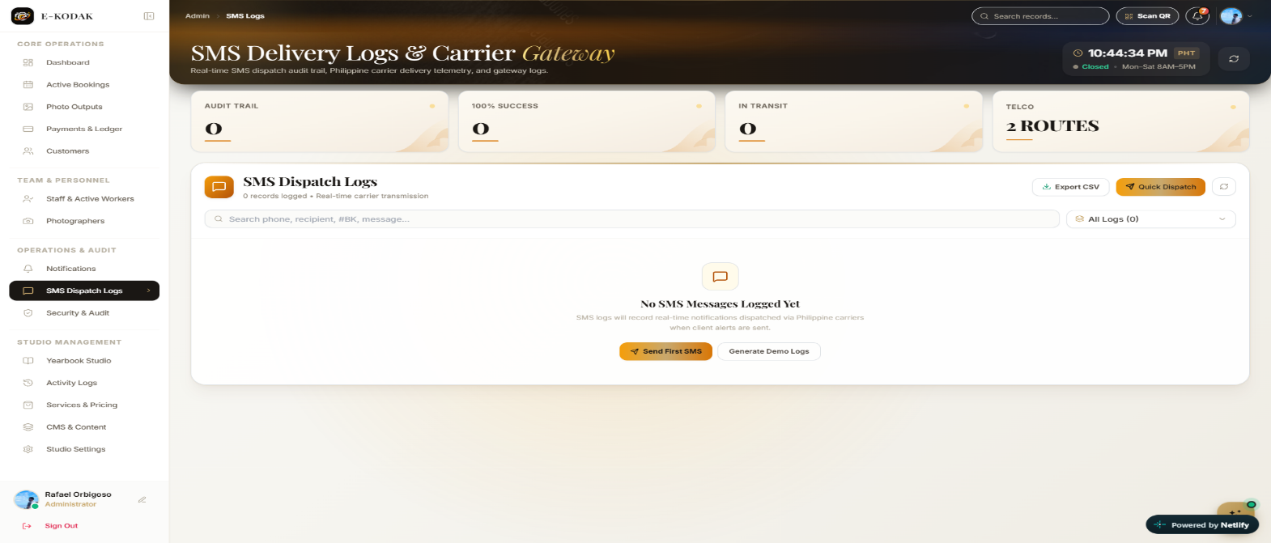
Figure 55
SMS
Figure 38 shows the monitoring and recording of SMS messages sent to clients.

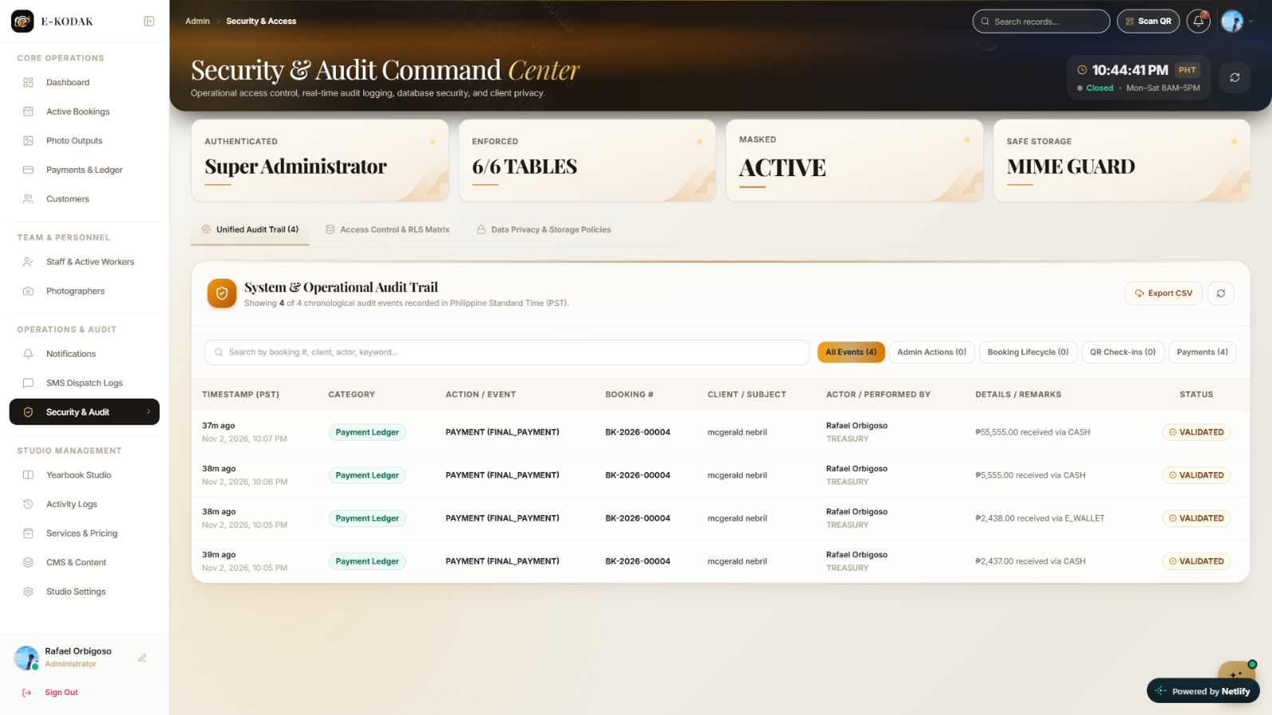
Figure 56
Security
Figure 39 shows the monitoring of system audit records, payment transactions, and security activities.

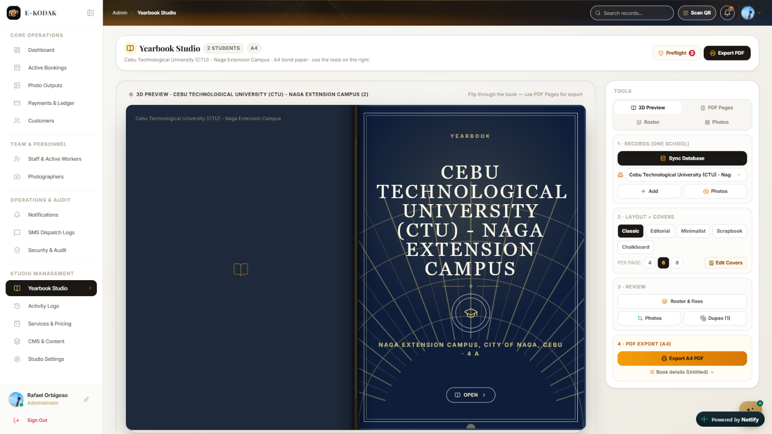
Figure 57
Year Book Studio

Figure 40 shows the tools for designing yearbooks, managing student photos, and exporting PDF files.

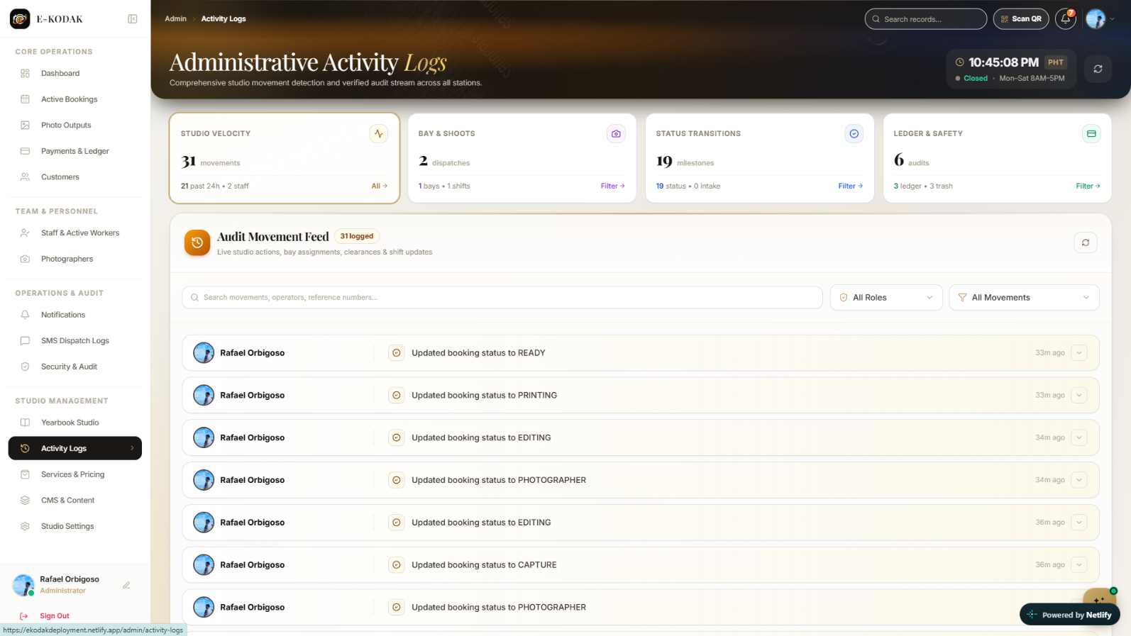
Figure 58
Activity Logs

Figure 41 shows the recording of administrative activities and booking status updates.

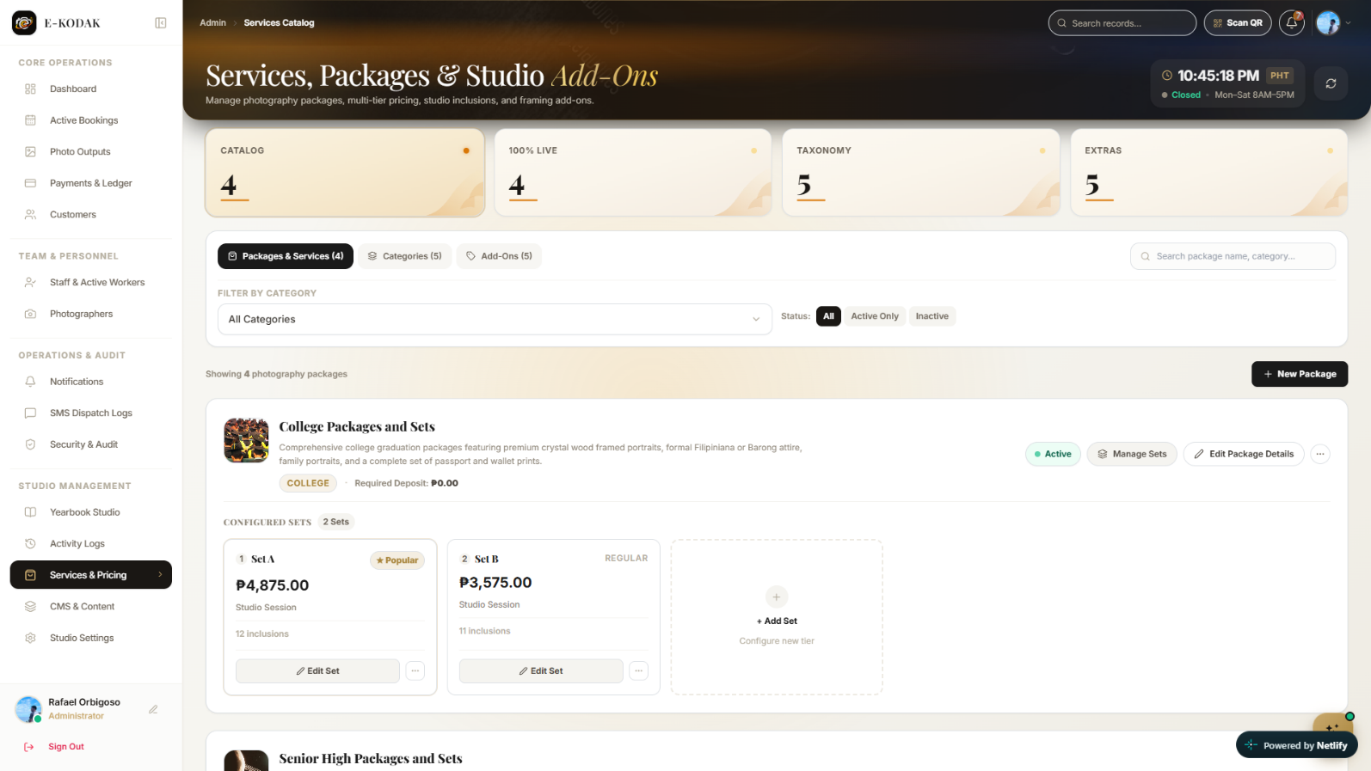
Figure 59
Service&Pricing

Figure 42 shows the management of photography packages, prices, and additional services.

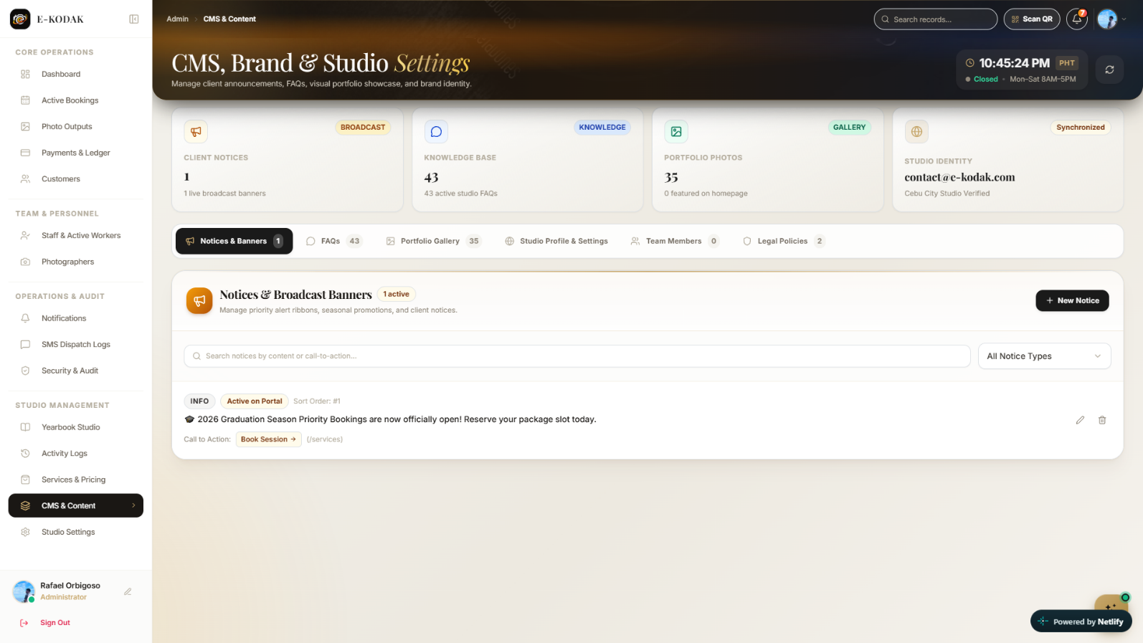
Figure 60
CMS&Content
Figure 43 shows the management of studio announcements, FAQs, portfolio photos, and website content.

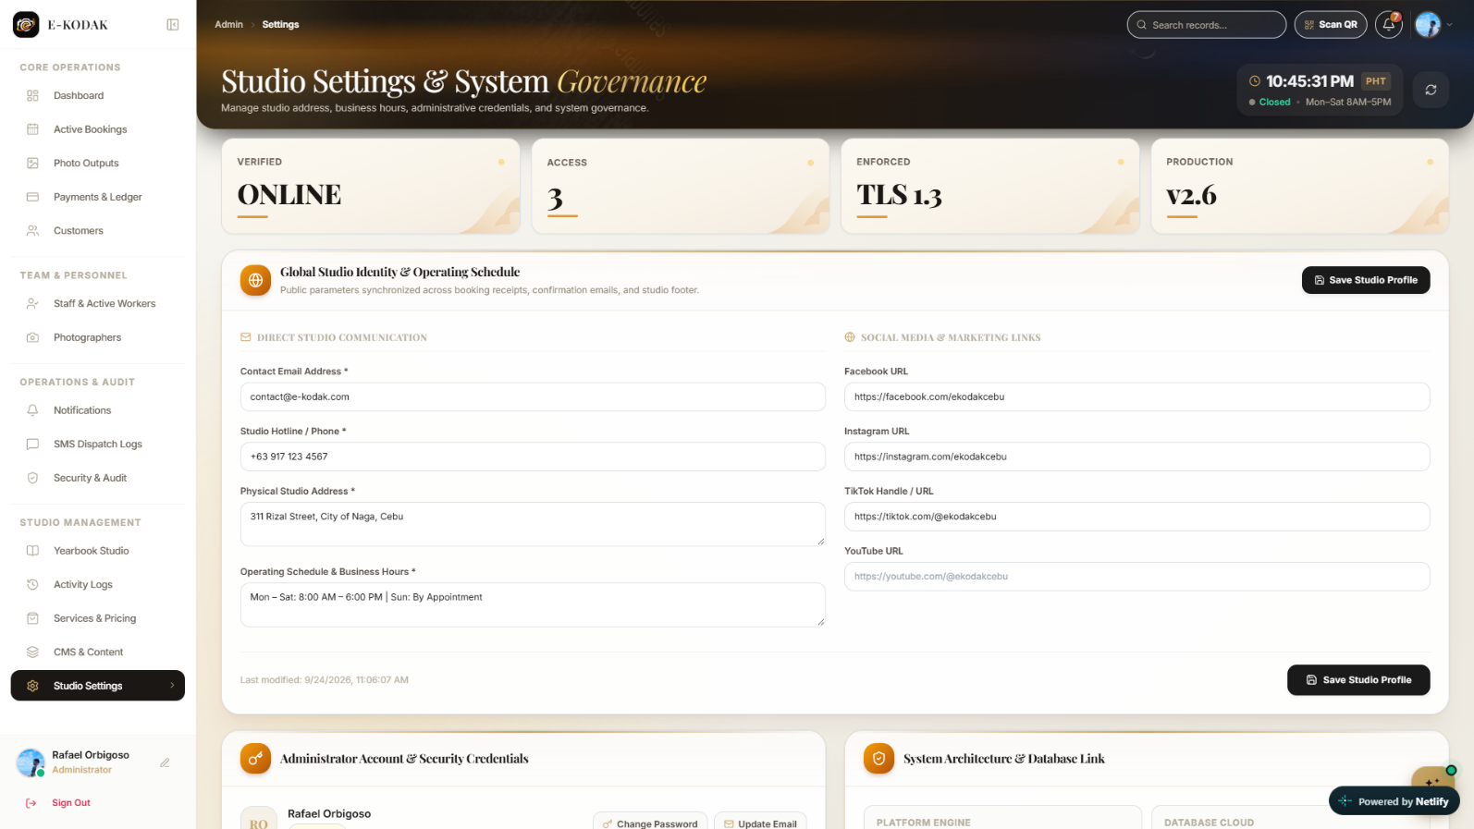
Figure 61
Studio Settings

Figure 44 shows the configuration of studio information, business hours, contact details, and system settings.

System Evaluation Results
The following sections and discussion present the results of the system evaluation based on the software-quality areas included in the E-KODAK questionnaire. The computation used the 37 submitted responses in the uploaded survey spreadsheet. Each item mean and weighted mean was computed by assigning numerical values to the five-point Likert responses.
Functionality of the System
QUESTION | MEAN | VERBAL INTERPRETATION
1. E-KODAK provides the necessary functions for managing photography bookings and service transactions. | 4.49 | Strongly Agree (SA)
2. E-KODAK correctly records and manages customer, booking,photographer, service, and photo-production information. | 4.49 | Strongly Agree (SA)
3. E-KODAK allows authorized personnel to assign photographers and update the status of photography services and outputs. | 4.57 | Strongly Agree (SA)
4. E-KODAK provides QR-based functions for identifying and tracking applicable photography transactions. | 4.38 | Strongly Agree (SA)
5. E-KODAK provides the necessary functions for managing photo output, yearbook records, notifications, and related photography_x0002_ service activities. | 4.43 | Strongly Agree (SA)
Weighted Mean | 4.47 | Strongly Agree (SA)

The results present the respondents’ assessment of E-KODAK in terms of functionality. The weighted mean was 4.47, interpreted as Strongly Agree (SA). Item 3 obtained the highest item mean of 4.57. The result indicates that the respondents generally rated this area of the system as Strongly Agree.
Efficiency of the System
QUESTION | MEAN | VERBAL INTERPRETATION
1. E-KODAK loads booking, customer, photographer, and service information within an acceptable amount of time. | 4.43 | Strongly Agree (SA)
2. E-KODAK responds promptly when authorized users search, view, or update photography-service records. | 4.32 | Strongly Agree (SA)
3. E-KODAK processes booking and photography-service transactions within an acceptable amount of time. | 4.38 | Strongly Agree (SA)
4. OR-based transaction identification and status processing are completed within an acceptable amount of time. | 4.38 | Strongly Agree (SA)
5. E-KODAK generates applicable notifications and synchronizes updated information within an acceptable amount of time. | 4.41 | Strongly Agree (SA)
Weighted Mean | 4.38 | Strongly Agree (SA)

The results present the respondents’ assessment of E-KODAK in terms of efficiency. The weighted mean was 4.38, interpreted as Strongly Agree (SA). Item 1 obtained the highest item mean of 4.43. The result indicates that the respondents generally rated this area of the system as Strongly Agree.
Compatibility of the System
QUESTION | MEAN | VERBAL INTERPRETATION
1. The E-KODAK web portal functions properly on the supported computers and web browsers. | 4.46 | Strongly Agree (SA)
2. The E-KODAK mobile application functions properly on supported mobile devices. | 4.41 | Strongly Agree (SA)
3. The web portal and mobile application exchange photography_x0002_ service information consistently. | 4.43 | Strongly Agree (SA)
4. QR-code functions operate properly on the supported mobile devices and system components. | 4.51 | Strongly Agree (SA)
5. E-KODAK functions properly within the hardware, software, database, and network environment used by the photography service. | 4.54 | Strongly Agree (SA)
Weighted Mean | 4.47 | Strongly Agree (SA)

The results present the respondents’ assessment of E-KODAK in terms of compatibility. The weighted mean was 4.47, interpreted as Strongly Agree (SA). Item 5 obtained the highest item mean of 4.54. The result indicates that the respondents generally rated this area of the system as Strongly Agree.
Usability of the System
QUESTION | MEAN | VERBAL INTERPRETATION
1. The E-KODAK interface is easy to understand and navigate. | 4.38 | Strongly Agree (SA)
2. The labels, buttons, menus, instructions, and messages are clear and understandable. | 4.38 | Strongly Agree (SA)
3. Customers, photographers, and authorized staff can easily locate the functions relevant to their roles. | 4.43 | Strongly Agree (SA)
4. E-KODAK provides clear feedback or confirmation after important user actions. | 4.35 | Strongly Agree (SA)
5. Users can complete common photography-service tasks with minimal difficulty. | 4.32 | Strongly Agree (SA)
Weighted Mean | 4.37 | Strongly Agree (SA)

The results present the respondents’ assessment of E-KODAK in terms of usability. The weighted mean was 4.37, interpreted as Strongly Agree (SA). Item 3 obtained the highest item mean of 4.43. The result indicates that the respondents generally rated this area of the system as Strongly Agree.
Reliability of the System
QUESTION | MEAN | VERBAL INTERPRETATION
1. E-KODAK operates consistently during normal photography-service activities. | 4.41 | Strongly Agree (SA)
2. E-KODAK is available when customers, photographers, orauthorized personnel need to access it under supported operating conditions. | 4.41 | Strongly Agree (SA)
3. E-KODAK consistently stores booking, transaction, photographer, and photo- status information accurately. | 4.46 | Strongly Agree (SA)
4. E-KODAK preserves properly saved information when an unexpected interruption occurs. | 4.38 | Strongly Agree (SA)
5. QR-based transaction tracking and automated status notifications operate consistently when the required services are available. | 4.24 | Strongly Agree (SA)
Weighted Mean | 4.38 | Strongly Agree (SA)

The results present the respondents’ assessment of E-KODAK in terms of reliability. The weighted mean was 4.38, interpreted as Strongly Agree (SA). Item 3 obtained the highest item mean of 4.46. The result indicates that the respondents generally rated this area of the system as Strongly Agree.
Security of the System
QUESTION | MEAN | VERBAL INTERPRETATION
1. E-KODAK requires appropriate authentication before protected photography- service information can be accessed. | 4.32 | Strongly Agree (SA)
2. E-KODAK restricts users to functions and information appropriate to their assigned role. | 4.41 | Strongly Agree (SA)
3. E-KODAK helps protect customers' personal information and photography- service records from unauthorized access. | 4.41 | Strongly Agree (SA)
4. E-KODAK helps prevent unauthorized modification of bookings, photographer assignments, transactions, and photo records. | 4.35 | Strongly Agree (SA)
5. E-KODAK provides appropriate protection for user accounts and confidential information during normal use. | 4.38 | Strongly Agree (SA)
Weighted Mean | 4.37 | Strongly Agree (SA)

The results present the respondents’ assessment of E-KODAK in terms of security. The weighted mean was 4.37, interpreted as Strongly Agree (SA). Item 2 obtained the highest item mean of 4.41. The result indicates that the respondents generally rated this area of the system as Strongly Agree.
Maintainability of the System
QUESTION | MEAN | VERBAL INTERPRETATION
1. The system components are organized in a manner that supports maintenance and modification. | 4.43 | Strongly Agree (SA)
2. System errors and maintenance issues can be efficiently identified and corrected. | 4.38 | Strongly Agree (SA)
3. Individual system components can be modified without unnecessarily affecting unrelated functions. | 4.30 | Strongly Agree (SA)
4. System updates can be implemented without significantly disrupting normal photography-service operations. | 4.46 | Strongly Agree (SA)
5. Modified or newly added functions can be adequately tested before deployment. | 4.32 | Strongly Agree (SA)
Weighted Mean | 4.38 | Strongly Agree (SA)

The results present the respondents’ assessment of E-KODAK in terms of maintainability. The weighted mean was 4.38, interpreted as Strongly Agree (SA). Item 4 obtained the highest item mean of 4.46. The result indicates that the respondents generally rated this area of the system as Strongly Agree.
Portability of the System
QUESTION | MEAN | VERBAL INTERPRETATION
1. E-KODAK can adapt when photography-service or booking requirements change. | 4.41 | Strongly Agree (SA)
2. E-KODAK can accommodate additional service categories, photography packages, and applicable event types. | 4.41 | Strongly Agree (SA)
3. E-KODAK can accommodate additional customers, photographers, staff accounts, and transaction records. | 4.32 | Strongly Agree (SA)
4. Additional photography-management or customer-service functions can be incorporated when future requirements arise. | 4.30 | Strongly Agree (SA)
5. E-KODAK can accommodate supported changes in system components without requiring complete redevelopment. | 4.32 | Strongly Agree (SA)
Weighted Mean | 4.35 | Strongly Agree (SA)

The results present the respondents’ assessment of E-KODAK in terms of portability. The weighted mean was 4.35, interpreted as Strongly Agree (SA). Item 1 obtained the highest item mean of 4.41. The result indicates that the respondents generally rated this area of the system as Strongly Agree.
Summary of the System Evaluation

QUESTION | MEAN | VERBAL INTERPRETATION
Functionality | 4.47 | Strongly Agree (SA)
Efficiency | 4.38 | Strongly Agree (SA)
Compatibility | 4.47 | Strongly Agree (SA)
Usability | 4.37 | Strongly Agree (SA)
Reliability | 4.38 | Strongly Agree (SA)
Security | 4.37 | Strongly Agree (SA)
Maintainability | 4.38 | Strongly Agree (SA)
Portability | 4.35 | Strongly Agree (SA)
GRAND MEAN | 4.40 | Strongly Agree (SA)
Overall, E-KODAK obtained a grand mean of 4.40, interpreted as Strongly Agree (SA) based on the responses of 37 participants. This result summarizes the respondents’ ratings across the eight software-quality areas included in the questionnaire. The findings represent the submitted survey responses only.

Chapter 5

SUMMARY, CONCLUSION, AND RECOMMENDATIONS

Summary
This capstone project, entitled E-KODAK: A Photography Management System with Real-Time Tracking, addresses the need for a more organized way to present and coordinate photography services. The revised manuscript uses the deployed website (https://ekodakdeployment.netlify.app/) as the reference for the current web-based implementation and retains the original study’s focus on service information, customer access, booking coordination, and studio operations. The system is intended to reduce reliance on scattered inquiries and manual record handling by providing a central online point of access.
Chapters 1 and 2 discussed the problem context, project objectives, scope and limitations, and related literature on web-based booking, service management, QR technology, notifications, digital media handling, and software quality. Chapter 3 presented the organizational context and workflow. Chapter 4 described the development approach, requirements, system design, and evaluation procedures. These chapters were revised to distinguish the deployed website from features that remain objectives or require further verification.

Conclusion
E-KODAK provides a practical direction for organizing photography studio services through a web-based platform. The deployment gives the project a concrete online reference and can support the presentation of services and the studio’s digital workflow. However, the presence of a live website alone does not establish that every proposed capability—such as QR-based status tracking, automated SMS notifications, photo-release monitoring, or yearbook management—works end to end. Those capabilities should be described as implemented only after direct functional testing and confirmation against the current source code and database configuration.
The study therefore concludes that E-KODAK is a useful step toward digitizing photography service management, while the completeness, reliability, usability, and security of individual modules must be established through documented testing and user evaluation. Any claims about performance or user satisfaction should be based on the actual evaluation records rather than assumed from the deployment.

Recommendations
1. Verify each feature against the deployed system. Test registration and login, service/package browsing, booking submission, booking status changes, customer records, and every administrative function that is available. Record the test date, expected result, actual result, and evidence for each test.
2. Confirm optional or advanced modules. Before presenting QR tracking, automated SMS notifications, photo-output status monitoring, payments, or yearbook management as completed features, verify that each module is accessible, connected to its required services, and functioning in the deployed version.
3. Strengthen data protection. Review authentication and authorization rules, validate user input, protect customer contact details and uploaded photographs, avoid exposing service credentials in client-side code, and ensure that database policies restrict access according to user roles.
4. Improve responsive usability. Test the website on desktop and mobile screens, check navigation and form validation, provide clear feedback for errors and successful actions, and ensure that important booking information is readable and accessible.
5. Maintain reliable records and backups. Establish routine database backups, document how records and media are stored, and prepare recovery procedures for accidental deletion or service interruption.
6. Conduct and document system evaluation. Use a defined test plan and an appropriate software-quality instrument. Present the actual respondent count, scoring procedure, computed results, and interpretation. Do not insert assumed means, percentages, or reliability values.
7. Update the technical documentation. Keep the system architecture, data model, deployment instructions, user roles, and feature list aligned with the current repository and live website. Revise the manuscript whenever a feature is added, removed, or changed.
8. Consider future enhancements. After confirming the stability of the current system, the developers may improve booking-calendar coordination, QR-based transaction lookup, automated customer notifications, controlled photo delivery, yearbook organization, audit logging, and analytics according to the studio’s priorities and available resources.

BIBLIOGRAPHY

REFERENCES

The Digital Transformation of SMEs. (2021). In OECD Studies on SMEs and Entrepreneurship. OECD Publishing. https://doi.org/10.1787/bdb9256a-en
Verhoef, P. C., Broekhuizen, T., Bart, Y., Bhattacharya, A., Qi Dong, J., Fabian, N., & Haenlein, M. (2021). Digital transformation: A multidisciplinary reflection and research agenda. Journal of Business Research, 122, 889–901. https://doi.org/10.1016/j.jbusres.2019.09.022

Bharadwaj, A., El Sawy, O. A., Pavlou, P. A., & Venkatraman, N. (2013). Digital Business Strategy: Toward a Next Generation of Insights. MIS Quarterly, 37(2), 471–482. https://doi.org/10.25300/misq/2013/37:2.3

Computer Systems: A Programmer’s Perspective. (2023). Pearson.com. https://www.pearson.com/en-us/subjectcatalog/p/managementinformation systems/P200000003479
Zeqiri, J., Alserhan, B., Gleason, K., & Ramadani, V. (2022). Desecularization, Social Identity, and Consumer Intention to Purchase Religious Products. Technological Forecasting and Social Change, 177, 121522. https://doi.org/10.1016/j.techfore.2022.121522

Nambisan, S., et al. (2019). Digital innovation management: Reinventing innovation management research in a digital world. MIS Quarterly. OECD (2021). SME Digitalisation to “Build Back Better”.

Zhao, P., Yoo, I., Lavoie, J., Lavoie, B. J., & Simoes, E. (2017). Web-Based Medical Appointment Systems: A Systematic Review. Journal of Medical Internet Research, 19(4), e134. https://doi.org/10.2196/jmir.6747

Permatasari, H., Purwanto, E., & Triyono, T. (2023). ANALYSIS OF THE ROLE OF RESERVATION SYSTEMS IN IMPROVING CUSTOMER EXPERIENCE IN THE SALON AND SPA INDUSTRY: LITERATURE
REVIEW. Proceeding of International Conference on Science, Health, and Technology, 220–228. https://doi.org/10.47701/icohetech.v4i1.3395

K. Naresh, & Mahesh, V. (2024). Online Photography Booking System. Shodhshauryam International Scientific Refereed Research Journal, 7(2), 384–389. https://doi.org/10.32628/SHISRRJ247263

Reyes, J., & Dela Cruz, M. (2023). Assessment of Booking Practices in Philippine Service Enterprises. Journal of Philippine Business Research (local study).

Garcia, A., Santos, P., & dela Vega, L. (2024). Digital Transformation in Local Service Businesses in the Philippines. Philippine Journal of Information Systems. IJCRT (2025). Features of Effective Online Booking Systems. IJCRT Volume 13.

Dey, N., Ashour, A. S., & Balas, V. E. (2021). QR Codes in Intelligent Systems: A Survey. Springer. https://link.springer.com/book/10.1007/978-3-030-55523

Singh, A., & Rana, S. (2020). QR Code-Based Inventory System for Retail Services. International Journal of Emerging Technologies. https://doi.org/10.1109/ICETEST48712.2020.

Lee, S., Park, J., & Choi, H. (2021). Customer Experience Improvement Through QR Code Applications in Retail. Journal of Retail Technology. https://www.sciencedirect.com/science/article/pii/S096969892100034

Mahmood, A., & Chowdhury, H. (2022). Service Workflow Automation Using QR Technologies. International Journal of Service Software Engineering. https://doi.org/10.4018/IJSSE.2022010102

Hernandez, R., & Caballes, J. (2024). Digital Check-In System Using QR Codes in Philippine Event Services. Philippine Journal of Digital Innovations Bangko Sentral ng Pilipinas (2023). QR Ph Standard and Mobile Payment in the

Philippines.https://www.bsp.gov.ph/Pages/MediaAndResearch/QRPh.aspx

Madan, A., et al. (2021). Global QR Code Integration in Digital Wallets and Verification Services. IEEE Communications Surveys & Tutorials. https://doi.org/10.1109/COMST.2021.3050937

Ulloa-Pérez, E., et al. (2022). Pragmatic randomized study of targeted text message reminders to reduce no-shows. PMC. https://pmc.ncbi.nlm.nih.gov/articles/PMC9126539/

Fischer, H. H., Moore, S. L., Johnson, T. L., Everhart, R. M., Batal, H., & Davidsoni,

A. J. (2017). Appointment reminders by text message in a safety net health care system: a pragmatic investigation. PMC. https://pmc.ncbi.nlm.nih.gov/articles/PMC5983071/

Schwebel, F. J., & Larimer, M. E. (2018). Using text message reminders in health care services: a narrative literature review. Internet Interventions. https://pubmed.ncbi.nlm.nih.gov/30206523/

Pagay-Cierva, M. J., Garciano, A. G. P., Borong, J. Q., & Flores, R. (2025). Enhanced mobile-based records management and e-payment with SMS notification. International Journal of Research and Innovation in Social Science.

Reyes, F. M., et al. (2022). Event management system with SMS notification for Mindanao People’s Care Foundation, Inc. Psychology and Education: A Multidisciplinary Journal. https://ejournals.ph/article.php?id=20440

Behm, A. (2025). How SMS reminders improve communication and business processes.
Robotham, D. (2016). Using digital notifications to improve attendance in clinic. BMJ Open. https://bmjopen.bmj.com/content/6/10/e012116 Philippine SMS notification system implementation case. (2019). International Journal of Advanced Research in Computer Science.

Tripathi, G., Abdul Ahad, M., & Paiva, S. (2020). SMS: A Secure Healthcare Model for Smart Cities. Electronics, 9(7), 1135.
https://doi.org/10.3390/electronics9071135

Danish, M., Sobrados, E., Kaushik, P., Acharya, B., Saad, M., Mueen, A., Rahaman, S., & Anwar, A. (2026). Private Links, Public Leaks: Consequences of Frictionless User Experience on the Security and Privacy Posture of SMS-Delivered URLs. ArXiv.org. https://arxiv.org/abs/2601.09232?

Paquet-Clouston, M., Haslhofer, B., & Dupont, B. (2019). Ransomware payments in the Bitcoin ecosystem. Journal of Cybersecurity, 5(1). https://doi.org/10.1093/cybsec/tyz003

Mantikayan, J. M., Abdulgani, M. A., Mohamad, H., Faheem Aliuden, Tarhata Guiamalon, Sema Dilna, Sittie Zohereya Nawal, & Reyes, F. (2022). Event Management System with SMS Notification for Mindanao People’s CareFoundation, Inc.

Joshi, M. R., & Pathak, V. M. (2026). A survey of SMS based Information Systems.

ArXiv.org. https://arxiv.org/abs/1505.06537?

Yuwono, T., Suroso, A., & Novandari, W. (2024). Information and communication technology in SMEs: a systematic literature review. Journal of Innovation and Entrepreneurship, 13(1). https://doi.org/10.1186/s13731-024-00392-6

Oestreicher-Singer, G., & Zalmanson, L. (2013). Content or Community? A Digital Business Strategy for Content Providers in the Social Age1. MIS Quarterly, 37(2), 591–616. https://doi.org/10.25300/misq/2013/37.2.12 Issue
Information. (2020). Information Systems Journal, 30(3). https://doi.org/10.1111/isj.12248

Mantikayan, J. M., Abdulgani, M. A., Mohamad, H., Faheem Aliuden, Tarhata Guiamalon, Sema Dilna, Sittie Zohereya Nawal, & Reyes, F. (2022). Event Management System with SMS Notification for Mindanao People’s CareFoundation, Inc. Psychology and Education: A Multidisciplinary Journal, 3(7), 1–1.

Bharadwaj, A., El Sawy, O. A., Pavlou, P. A., & Venkatraman, N. (2013). Digital business strategy: Toward a next generation of insights. MIS Quarterly, 37(2), 471–482.

Dizon, M. A., Reyes, J. L., & Torres, P. R. (2023). Adoption of digital service systems in Philippine SMEs. Philippine Journal of Business Innovation, 12(1), 55–68.

Keesara, S., Jonas, A., & Schulman, K. (2020). COVID-19 and health care’s digital revolution. New England Journal of Medicine, 382(23), e82.

Marston, S., Li, Z., Bandyopadhyay, S., Zhang, J., & Ghalsasi, A. (2011). Cloud computing—The business perspective. Decision Support Systems, 51(1), 176–189.

Ong, J. T., Cruz, K. L., & Santos, R. M. (2022). Digital transformation in Philippine SMEs: Adoption and challenges. Asia Pacific Journal Management and Sustainability, 8(2), 101–115.

Porter, M. E., & Heppelmann, J. E. (2015). How smart, connected products are transforming companies. Harvard Business Review, 93(10), 96–114.

Susanti, D., Nugroho, Y., & Prasetyo, A. (2023). Implementation of web-based integrated information systems in service industries. Journal of Information Systems Engineering and Business Intelligence, 9(1), 34.

Vial, G. (2019). Understanding digital transformation: A review and a research agenda. Journal of Strategic Information Systems, 28(2), 118–144.

Bharadwaj, A., El Sawy, O. A., Pavlou, P. A., & Venkatraman, N. (2013). Digital business strategy: Toward a next generation of insights. MIS Quarterly, 37(2), 471–482.

Dizon, M. A., Reyes, J. L., & Torres, P. R. (2023). Adoption of digital service systems in Philippine SMEs. Philippine Journal of Business Innovation, 12(1), 55–68.
Keesara, S., Jonas, A., & Schulman, K. (2020). COVID-19 and health care’s digital revolution. New England Journal of Medicine, 382(23), e82.

Marston, S., Li, Z., Bandyopadhyay, S., Zhang, J., & Ghalsasi, A. (2011). Cloud computing—The business perspective. Decision Support Systems, 51(1), 176–189.
Porter, M. E., & Heppelmann, J. E. (2015). How smart, connected products are transforming companies. Harvard Business Review, 93(10), 96–114.
Susanti, D., Nugroho, Y., & Prasetyo, A. (2023). Implementation of web-based integrated information systems in service industries. Journal of Information Systems Engineering and Business Intelligence, 9(1), 34–42.
Vial, G. (2019). Understanding digital transformation: A review and a research agenda. Journal of Strategic Information Systems, 28(2), 118–144.

.

